We know that Windows Vista and Windows 7 come with a new Start menu which is easy to use and full of new features such as instant search, etc. Unfortunately Microsoft has removed this Start Menu from Windows 8.
If you have upgraded to Windows 8 and want to get Start Menu back, this topic will help you.
And if you are still using Windows XP and don't want to upgrade to Windows Vista or Windows 7 but want to have the same Start Menu functionality in XP, then this topic will also help you.
Today in this topic, we are going to share a free software "ViStart" which can bring back Windows Vista or Windows 7 style Start Menu to Windows XP and Windows 8.
ViStart is an excellent piece of software created by our friend "Lee Matthew Chantrey" which can be considered as Windows Vista and Windows 7 Start menu clone for Windows XP and Windows 8. It integrates itself into Windows Explorer perfectly. It replaces the default Windows Start Menu and brings the new Windows Vista and 7 style Start Menu to XP and Windows 8.
It indexes all program files and personal files, so you can get the same instant search results as of Windows Vista and Windows 7, even better than Vista.
ViStart also comes with skin support, so you can create your own ViStart skins and can change its look.
#1 Create a folder on your desktop called “start”
#2 Create a new toolbar on the toolbar and point it to the “start” folder you just created
#3 Install ViStart software
#4 Restart may be required
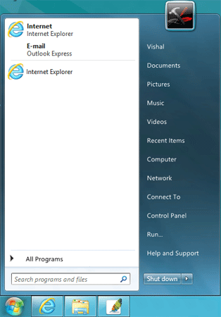
Features List:
- Provides original features of Windows 7 Start Menu in Windows XP and Windows 8
- Boots directly to Windows 8 Desktop, bypasses Metro Start Screen
- Advanced search (includes Metro apps and displays them in a separate category)
- Search and start Metro apps directly from Start Menu
- Pin Metro apps to Start Menu
- Switch button in Start Menu to switch to Start Screen
- Ability to customize Start button
- Skin support
You can download it using following link:
Download Link

