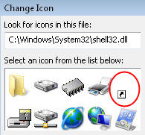
Background Shortcut's Arrow
The shortcut arrow is actually an overlay, which is stored in the master icon file called shell32.dll. If you open this file, then you will see familiar icons for folders, CD Drives and Start Menu items (see screenshot). Now each icon has a number associated with it, and the shortcut's number is 29. What we will do is launch the registry editor, and redirect number 29 to a different icon, one that is transparent.
Incidentally, to see the shell32.dll icons, right-click any shortcut, select Change Icon and browse to windows\system32\shell32.dll.

Method 1 (Best): Remove Arrows with Shell Icons
Our mission is to tweak the registry so that we can remove arrows on shortcuts icon. As a preliminary step, make sure that you have a shortcut on your desktop, then you will be able to see the changes, for example, create a shortcut to calc.exe.
Note: Unlike many registry hacks, this only works on Vista (and not XP).

Registry Instructions for Shell Icons Method
- Launch Regedit.
Navigate to this path:
** HKLM\SOFTWARE\Microsoft\Windows\CurrentVersion\explorer\
- Underneath \explorer, create:
a) A new Key called: Shell Icons (note plural)
b) In Shell Icons, create a new REG_SZ called: 29
c) Note: Kristi says: create a new REG_EXPAND_SZ called: 29.
- Assign to 29 a value of: %SystemRoot%\noarrow.ico,0
- Note: noarrow.ico must refer to the name of the file that you add to the %systemroot% folder.
In other words, download noarrow.ico, extract the file and copy it to the \Windows folder.
- Once you have edited the registry, and copied the noarrow.ico file, then logoff and log back on again. (If something goes wrong, or you try several experiments, you may need to restart.)

Screen Shot of Shell Icons

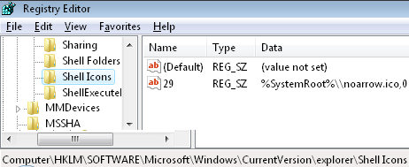
Method 2: Remove Arrows on Shortcuts by Deleting IsShortCut
Once again, I will show you how to remove arrows on shortcut icons. This method involves deleting a registry value, so I advise that you export at least the HKEY_CLASSES_ROOT\linkfile branch of the Vista registry.

Side Effects of Deleting IsShortCut
If you delete the registry REG_SZ IsShortCut, then the Favorite Links disappear. Another problem occurs with the Media Center and Games Explorer, their shortcuts may be displayed, but they don't work when you click on them. On the other hand the Shell Icons method has no such side effects, although there is no arrow, the icon still launches the underlying program.

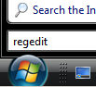
Registry Instructions for IsShortCut
- Launch Regedit.
Navigate to this path:
*** HKEY_CLASSES_ROOT\linkfile
- Rename a REG_SZ called IsShortCut to IsNotShortCut
Alternatively, delete IsShortCut altogether.
- Seek more instances of IsShortCut. Here is a classic case for using 'Find' and F3 to search for more occurrences of IsShortCut. In particular, look for more instances of IsShortCut at:
HKCR\piffile and HKCR\WSHFile. You may even find more IsShortCut entries under HKLM\Software\Classes.

