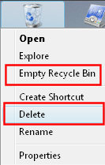
Why People Delete the Recycle Bin
An understanding of why people delete their recycle bin will help us prevent further occurrences of this problem.
It seems to me that Microsoft has tried to provide extra features for Vista in general, and for the Recycle Bin in particular. Unfortunately, in the case of the Recycle Bin they underestimated users' ability to read and understand the menus.
Confusion is caused by the two options, 'Delete' or 'Empty Recycle Bin'. When people decide to empty their rubbish, their brain is already thinking 'delete'. So when they see the word 'Delete' on the bin's shortcut menu, they click on that instead of looking for the option to 'Empty Recycle Bin'.
As a result of making the wrong choice, the user is surprised when the Recycle Bin disappears from the desktop! Incidentally, the reason this deleted recycle bin problem has suddenly surfaced, is that in XP you cannot delete the Recycle Bin in the manner described above. The overall message is: more features mean more chances of making a mistake.

Quick Instructions to Find the Lost Recycle Bin
1) right-click the Vista Desktop
2) Click on Personalize
3) Select: 'Change desktop icons'
4) At the Desktop Icon Settings, place a tick next to: 'Recycle Bin'.

Example 1: Remove Delete from the Recycle Bin Properties
Here is an ideal solution for when you have an incompetent user, who keep on deleting their Recycle Bin, and then pesters you to cure their clumsiness. My mission is to edit the registry and re-program the Recycle Bin's short cut menu.
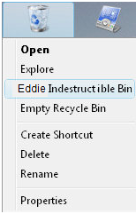
1) In Regedit, navigate to the following key:
HKCR\CLSID\{645FF040-5081-101B-9F08-00AA002F954E}
2) To create a new registry Key called 'Shell', click on the Edit Menu, New, select: Key and name it 'Shell'. You should now have:
HKCR\CLSID\{645FF040-5081-101B-9F08-00AA002F954E}\Shell
3) Under Shell create a new (Sub) Key called 'Delete'. Click on the Edit Menu, New, select: Key. You should now have:
HKCR\CLSID\{645FF040-5081-101B-9F08-00AA002F954E}\Shell\Delete
4) Edit the 'Default' REG_SZ, as this is just a string value for display you could set to anything you like, for example 'YourName's Indestructible Bin'.

