Instructions for LocalizedString
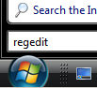
The mission is to find a specific class id (CLSID) in HKEY_CLASSES_ROOT, and then change the value for LocalizedString from 'Computer' to a variable which will reflect the user who logs on to this particular computer.
Launch Regedit and navigate thus:
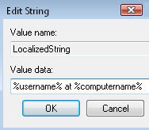
0) Precaution: Rename the existing value:
Locate with regedit HKEY_CLASSES_ROOT\CLSID\
{20D04FE0-3AEA-1069-A2D8-08002B30309D} rename LocalizedString to LocalizedString.Old
1) Create a new VALUE. Note type should be Expanded String Value. Name it: LocalizedString
2) Edit the 'Value data'. I double click LocalizedString, then click in the dialog box and type: %Username% at %Computername%
Incidentally, you could choose more creative words in place of 'at'. For example, 'King of' or 'Queen of'.
3) To see the fruits of your labours, just press F5 to refresh the desktop, your computer icon should now say the equivalent of: YourName at YourComputer.(See screenshot at the top of this page).

