Office 2012 Screenshot  
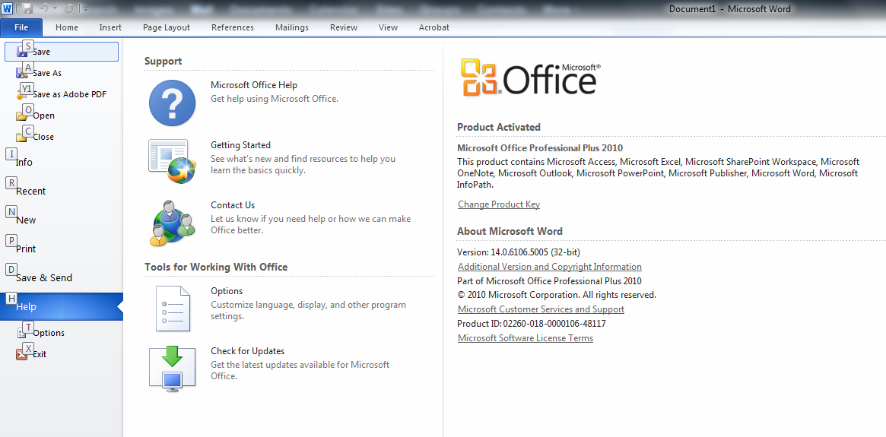  
  
  
Folder Structure Screenshot  
