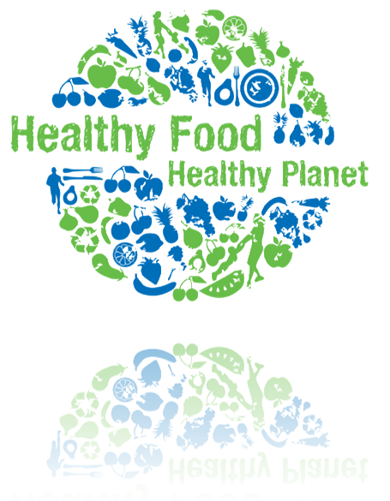
Big Ideas in Science: Food Origins
Eddie S. Jackson

Food Origins
Eddie S. Jackson
Kaplan University
SC300: Big Ideas in Science: From Methods to Mutation
When we speak about food origins, what exactly do we mean? In this case, we are
specifically implying where do the food components come from that make up our meals. If you
think about it, many types of elements of food and additives have to be brought together in a
delectable, well-orchestrated manner to provide us the meals that we have come to love. It is
almost too easy to forget or to take for granted where fruits, vegetables, meats, and condiments all
come from, which are all the building blocks of the meals we eat. Something as simple as salt can
literally cross oceans (thousands of miles) just to be a part of our regular servings of food.
Assessing the "food trail" and asking questions about general food processing is exactly what this
paper is about . I will delve into breakfast and dinner, and describe exactly what goes into the
meals, as well as how it becomes available for my general consumption. As I do all my shopping at
Wal-Mart, you can safely assume that all the products I mention have been purchased there.
Breakfast, some say the most important meal of the day, can require quite an elaborate list
of ingredients sometimes. However, my typical breakfast usually consists of pancakes, eggs, turkey
sausages, and orange juice; simple enough. Though, there is one tricky part, the pancakes. The
pancakes are actually a combination of a few components; I use flour, eggs, baking powder, and
salt (and sometimes vanilla). Whew! Just thinking about how all of these individual elements
made it to my kitchen can seem mysterious. With a little research though, I was able to begin the
tracking process of where my food came from. The Homemaker Orange Juice is from Longwood,
Florida (not too far really). The eggs I eat are Sunny Meadow, and they are from Jackson,
Mississippi (getting further away). The flour and baking powder I use to make the pancakes both
come from Bentonville, Arizona. And, the furthest of them all, is the McCormick’s Salt, it comes
all the way from France!
Dinner is a completely different list of food elements. A typical dinner in the
Jackson household is comprised of turkey burgers on hamburger buns, cheese, and southwestern
corn. The Jennie-O Turkey Burgers come all the way from Willmar, Minnesota, and the Merita
Hamburger Buns from Irving, Texas. The Colby Jack Cheese is from Plymouth, Wisconsin, and
finally the Green Giant Southwestern corn is from Minneapolis, Minnesota.
Beginning the trek of tracking our food from its origins, it all starts with the farmers.
Farmers grow the food. Then the farmers do basic containment of the food, and it is shipped to a
processing plant. At the processing plant, the food is then prepared and packaged for warehouses.
The food goes from the processing plant to the warehouses, which are also known as the
distribution centers. From the distribution centers, the food travels to grocery stores all over the
United States. And finally, I buy the food, and take it home to prepare it.
Just between the breakfast and dinner meals, my food comes from all over the United
States, and even part of it, from overseas. Even though it seems like most of the food comes from
America (used in my examples), actually the distribution centers that are typically on the food
labels, can be a little misleading. In some cases, the food actually comes from another country, and
then arrives for U.S. distribution at the national food warehouses. This would be a great example of
globalization. Globalization allows us to eat our favorite vegetable or fruit, even if it is out of
season within our own country. Globalization allows us to have many more products in general,
which are usually available year-round (and cheaper most of the time).
But with all the great food and economic benefits that globalization brings, there is
most definitely a serious, darker side. Because global products are made in other countries, the
regulation of pollution, chemical dumping and other environmental concerns (like the destruction
of rainforests), are sometimes not regulated at all, or at the very least, are less regulated. What this
leads to is a sense of out-of-sight out-of-mind, meaning if we do not see the damage to the planet,
we do not care about it. In the short term, we as Americans get to benefit from the availability of
products, but in the long run, the lack of universal governing laws, ultimately leads to ecological
and biological disasters.
There is a great phrase that goes, “Think Globally, Act Locally.” What this means to me
is to consider exactly what it takes to bring food to my table or products to my home. And, to
always take into account globalization, and how companies run their businesses at the international
level. In the case where you hear about companies abusing their industrial privileges, you should
do something about it. What do you do you may ask? You can do several things; you can start
with something as simple as writing a letter to your local congressman, or to something more active
like rallying and participating in peaceful marches. The main idea is to spread the word about the
poor industrial practices of some companies, and to educate as many people you can about the
possible ecological disasters that may lie ahead.
In the end, what does all this mean? It means our food comes from many different places
and that there are always questions that we could be and should be asking. How is my food
processed? Does this food come from America? Or does it come from another country? If my
food comes from another country, what are some of the regulations that govern the processing of
the food there? Through my research, I have learned it is important to ask and to seek answers to
these questions, not just because of one's personal health (though this is a good reason to know), but
also for the overall health of our planet. The things we do today, will affect us tomorrow. We need
to take care of our planet, so it can take care of us in the future. Where would we be without a
healthy planet?

References:
Trefil, James, & Hazen, Robert M. (2010). The Sciences An Integrated Approach. John Wiley & Sons, Inc.
www.nutritionaustralia.org (2010). Nutrition Week 2010 : Healthy Food; Healthy Planet. Retrieved on 02/13/2012, from http://www.nutritionaustralia.org/sites/www.nutritionaustralia.org/files/national/Healthy_food_Healthy_Planet_Web%5B1%5D.gif (Cover page).

