Humanities: Music
Eddie S. Jackson
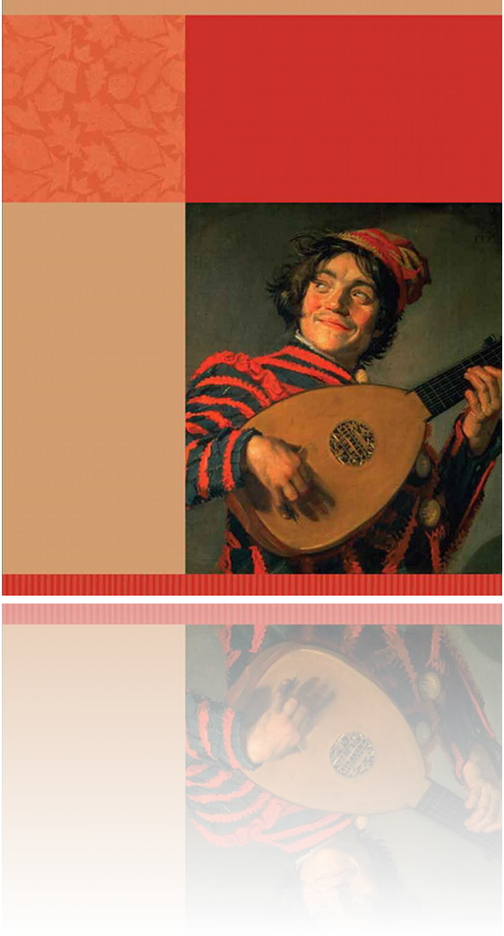

Music
Eddie S. Jackson
Kaplan University
HU300: Art and Humanities: 20th Century and Beyond

Why is music important? I have asked myself this question wondering if I could
provide a worthy depiction of why music is not only important to me, but should be
considered important to everyone. Music can let you soar to the highest emotional
heights; it can let you experience a full emotional range in such masterpieces like the
orchestrated music in symphonies. A nursery rhyme can transport you back in time to
when you were a child sitting in class singing with other classmates. A pop-culture song
on the radio can make you remember your first dance or that night at the senior prom. As
an adult, music can take you back to the first time you met your spouse or even provide
much needed relaxation after a long day’s work. Music is significant because it can
connect you to memories of the past as well as let you experience the musical world
through the creativity of an artist. This paper is about my musical journey from childhood
to teenager, from teenager to adulthood.
Oh, back in the early days, when my musical voyage began, there really was not
all that much music variety, I am sad to say. I grew up in the church and was shielded
from pop-culture and the music thereof. What I did get to experience was southern-gospel
music, bluegrass, and some light country music. It really does take me back every time I
hear “Amazing Grace” or “I’ll Fly Away”, classic gospel songs. I can picture myself sitting
at the piano in church chopping away at “The Old Rugged Cross”. There are even
people’s faces from the congregation that come to mind. Church music had its own
boundless quality. At times you could just feel the positive inspiration pouring from the
music, and at other times you could hear the sorrow meant to touch the hearts of its
listeners. For me, gospel music cracked the door into the musical world; though I soon
realized that the music of the church was not all there was.
During my teenage years, I began to branch out and broaden my music
repertoire. I was the typical teenager in that I had a rebellious streak. Not in the bad kid
kind of way, but in the “I want to do things my way”. So I started listening to radio
channels that played light pop music. Some music that I can remember that was quite
popular back then was “Amy Grant” and “Kenny G”; I ended buying their cassettes, which I
wore out in my Walkman. I really liked the fact both Amy Grant and Kenny G were not
gospel music, and at the same time allowed me to hear what different types of music
sounded like.
Of course, it did not stay light pop music for long. I gradually started moving
in to rock and roll, bands like “Guns and Roses” and “Metallica” were very popular at that
time. What I remember most from those bands was the energy, the anger, and of course
the great guitar riffs. After school and chores, I would put my headphones on and just get
lost in the music; it was how I escaped, escaped from everything. I spent years listening
to rock and roll and enjoyed every moment of it. Then eventually I moved into early
adulthood and my musical quest seemed to change, and off down a different path I went.
Early adulthood brought an interesting revolution in my music taste. I was
exposed to techno, of which I fell in love with immediately. The first techno song I ever
heard was “Halcyon” by Orbital, the year was 1995. I started delving into this new genre
of music with such enthusiasm, that I must have spent thousands of dollars buying
albums, and hundreds of hours listening to this ethereal music. Techno music fascinated
me. It definitely was not like gospel or rock and roll. It stood on its own. There is always
the beat of the techno song, the heartbeat of the music, and then comes layer after layer
of both real and synthetic instruments, allowing the listener to enjoy such audio range.
Some great techno artists that are popular right now are Paul Okenfold, DJ Tiesto, and
Armin van Buuren. Techno is definitely a new twist in my musical travels; though I have a
feeling it will not be the last.
Why is music important? Music is important because it is can be a musical
timeline of our memories; with just a few notes of a song, you can be taken back to grade
school or you can relive your first high school dance. Music can let you soar with the
eagles; attending a symphony can allow you to experience some of man’s audio
masterpieces. In my life, music has been a constant, ever-changing, magical and amazing
adventure. I love the musical journey I have been on thus far, and only look forward to
future excursions.
References:
Vincen (May 2003). USA Pictures. Retrieved (08/14/2011), from http://www.usa-pictures.com/photos-of-Florida-Orlando-656.photos
Altshuler, R. J. (2009). The Art of Being Human: The Humanities as a Technique for Living.

