The Space Race
Eddie S. Jackson
Kaplan University
LI499: Bachelor's Capstone in Liberal Studies
11/18/2013

Introduction
It was John F. Kennedy who said, “We choose to go to the Moon. We choose to go to the Moon in this decade and do the other things, not because they are easy, but because they are hard” (right); a historical statement spoken on
May 25, 1961 that would mark the beginning of the
United States’ greatest adventure, and start the countdown
to landing on the Moon (John F. Kennedy Presidential
Library and Museum, 2011). While the U.S. developing
space program led to major technological advancements in electrical, mechanical, and aeronautical engineering, which ultimately allowed Americans to land on the Moon, the Space Race would also change American society by affecting human behavior, human expression, and ethics on a national level.
To better understand the far-reaching effects of the U.S. space program, one needs to consider the historical timeline. The space program timeline begins in the post-World War II years, often referred to as the “golden age” of America. The economics and prosperity of the United States were expanding; its power was unchallenged; and, the nation was recognized as a leader on the world stage. However, there was a looming event that would not only challenge the United States’ growing power, but also change the course of its history.
Sputnik
The date was October 4, 1957 when the United States received word that the Soviet Union had successfully launched the world’s first artificial satellite into Earth’s orbit; it was known as Sputnik (see below) (Garber, 2007); Americans were stunned. The Sputnik event was highly significant because the successful
launch marked an enormous technical
achievement. Also, as stated by Gene Kranz
(2009), a NASA flight director, “The impact of
the first orbiting satellite, visible to the naked
eye as it passed through the night sky over American,
was profound.” Americans were caught off guard by this news due to the fact that the Soviet
Union was not known for being highly technological when it came to flight; the Soviets
were definitely not considered progressive enough for space flight. If the Soviet Union could launch a satellite into space, it would not be long before the country would have the ability to launch ballistic missiles extremely long distances; the scary part, which many Americans feared at the time, was that perhaps the Soviets already had long-range strike capability, and that these missiles could carry nuclear weapons from Europe to the United States (Garber, 2007). Thus, because of this new fear, and military, industrial awareness, the United States would form a new, more extensive space program, National Aeronautics and Space Administration (NASA); NASA would not only send man to the Moon and back, but would also act as a biodefense for the entire nation (Wagner, 2002); and, the Space Race had begun.
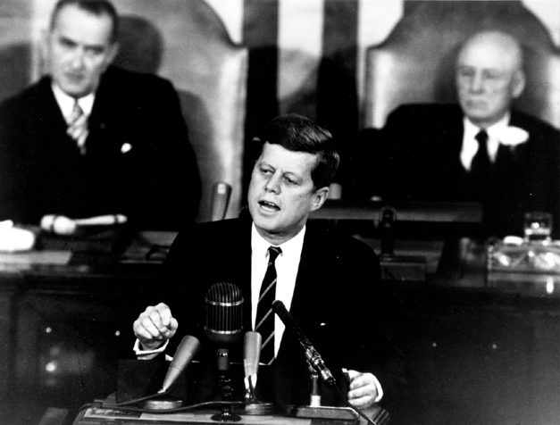
SOURCE: http://history.nasa.gov
The Space Programs
As the Space Race was newly underway, there were many difficulties in all the initial efforts. For instance, air flight was limited to high altitude just below low orbit. Also, since space flight was still quite a mystery to the United States, there were no guidelines, official documentation, or known procedures for getting a man into orbit. Rockets provided the only technology capable of carrying a man into space; however no man had ever survived the blast off the top of a rocket. One famous rocket, the X15, was tested at 600,000 horse power; but even at that speed, it would have to fly four times its top speed to put a man into orbit (Green, 2008). While NASA was working on a strategy for testing rockets and making them safe for space flight, the U.S. space program would be formed.
The pioneer space program was called project Mercury. The Mercury program astronauts were Walter M. "Wally" Schirra Jr., Donald K. "Deke" Slayton, John H. Glenn Jr., M. Scott Carpenter, Alan B. Shepard Jr., Virgil I. "Gus" Grissom and L. Gordon Cooper, Jr. (Green, 2008). These first American astronauts, the Mercury Seven, would become instant sensations in the media; radio, television, and newspapers would track their every move. The Mercury program, just like all the following space programs, would have goals that would have to be completed before moving on to the next program. Specifically, the Mercury program goals were: orbiting a manned spacecraft around Earth, investigating man's ability to function in space, and recovering both man and spacecraft safely (NASA). Very shortly after the Mercury program was considered a success, new members of the next space program were selected.
The second American space program was named project Gemini. The Gemini program astronauts were L. Gordon Cooper, Virgil "Gus" Grissom, Walter M. Schirra, Neil A. Armstrong, Frank Borman, Charles "Pete" Conrad, James A. Lovell, James A. McDivitt, Thomas P. Stafford, Edward H. White II, John W. Young, Edwin "Buzz" Aldrin, Eugene A. Cernan, Michael Collins, Richard F. Gordon, David R. Scott, (Green, 2008); many of these individuals would become some of NASA’s most famous astronauts. Just like the Mercury program, Gemini would also have mission goals, and these would build upon the successes of the Mercury program. The four goals of the Gemini program were: (1), developing operative systems of rendezvous and docking with other orbiting vehicles, and to operate the docked vehicles in space; (2), subjecting astronauts to longer periods of flights (a necessity for projected later trips to the Moon or deeper space); (3), acquiring supplementary information concerning the effects of weightlessness of space crew and to record their physiological reactions during extended duration flights; and (4), perfecting methods of re-entry and landing the spacecraft at a pre-selected landing point (NASA).
The third, and final, space program that would be created to put a man on the Moon was the Apollo program. The last of the astronauts that would take the United States to the Moon were Neil Armstrong, Buzz Aldrin, Pete Conrad, Alan Bean, Alan Shepard, Edgar Mitchell, David Scott, James Irwin, John W. Young, Charles Duke, Eugene Cernan, and Harrison Schmitt. The Apollo program had four colossal objectives: establishing the technology that would meet the United States’ national interests in space; becoming the number one nation in space exploration; exploring the Moon utilizing scientific procedures; and, developing man's competence of working on the lunar surface (NASA).
Each of these endeavors was important and critical to the overall success of the Moon landing. And yet, even as the drama of the Space Race unfolded, there were major changes and shifts happening in American society. These shared, cultural changes would affect human behavior, human expression, and would raise questions about ethics. The Space Race was important for the technological growth and global expansion of the United States, but also influenced changes that would positively impact the lives of Americans.
Human Behavior
When the discussion turns to the Space Race, you also have to include human behavior and emotions. There were a plethora of emotions associated with the Space Race. For example, happiness was related to the Space Race endeavors. Every time the U.S. had a successful rocket launch, completed a mission successfully, or designed and created a new form of technology, great happiness would be associated to it. One of the happiest moments of the space program was when the U.S. launched its first man into space. On May 5, 1961, Alan Shepard would be launched in the Freedom 7 spacecraft (Green, 2008). His twenty minute mission was proof that humans could survive and venture into space. Millions of Americans watched anxiously as Shepard left Earth, and, just twenty minutes later, Shepard successfully returned to Earth, proving that man could indeed survive in Earth’s lower orbit; the country would experience a great sense of happiness.
There was also inspiration and pride. The Space Race was highly competitive, mainly with the Soviet Union. Starting on October 4, 1957, when Sputnik had the world in awe, Americans would begin to challenge themselves in ways never attempted before. As the United States began pulling ahead of the Soviets in the Space Race, and maintaining the lead, so too did America regain its pride. According to Green (2008), a surge of pride happened when the United States completed its first orbital flight. On February 20, 1962, John Glenn would embark on the most dangerous and important mission of the U.S. space program to date. His mission would be the longest an American astronaut had been in space, and if successful, would pull the U.S. ahead of the Soviet Union in the Space Race. One hundred million people would watch the Friendship 7 launch; and, just five [seemingly] short hours later, Glenn returned to Earth. John Glenn would instantly become a national hero, and American pride would soar. Most significant, the United States would take the lead in the Space Race (Green, 2008).
However, not every aspect of the space program was joy and bliss; for there were moments of pain and sadness as well. For instance, in the early stages of the Space Race, a decision was made to send a chimpanzee, named Ham, into Earth’s orbit to prove that space flight would not be fatal to man. On January 31, 1961, NASA strapped Ham into a Mercury capsule and launched him into lower orbit, where he would perform several trained functions (Green, 2008). Shortly thereafter, NASA received word that the Soviet Union had successfully launched a man into space. This Soviet “cosmonaut,” Yuri Gragarin, would become the world’s first human in space (National Archives). Alan Shepard, along with the rest of the Mercury astronauts, was devastated and extremely frustrated by the news. The United States wanted to be the first in space, and could have beat the Soviet Union, but due to poor timing, and allowing Ham to be the first test pilot, the United States would have to forfeit the first man in space title.
There was also uncertainty and fear related to the space program. For example, what would happen if the United States lost the Space Race? What would happen if and when the United States lost astronauts? Fear was definitely a valid emotion as NASA, the astronauts, and many of the engineers were pushing the technology of the era to its limits. This created the potential for dangerous mistakes and/or catastrophes. And such a fear became reality in two major instances.
On July 21, 1961, when Gus Grissom returned to Earth in Liberty Bell 7, what should have been a routine ocean landing and pickup, turned into a near fatal disaster. After Grissom blew the main hatch to exit his capsule, seawater immediately poured in. There was a retrieval helicopter that was there to pick up Gus Grissom and the capsule, however, the helicopter engine was over-heating causing it to have problems maintaining control over the capsule. In the same instance, Grissom was helpless and desperate because his space suit was taking on water-- NASA was dangerously close to losing their first astronaut. Fortunately, a second helicopter rushed in to rescue Gus Grissom; the astronaut was saved, but the Liberty Bell 7 capsule sank in three miles of water and was lost.
The second, and most tragic, occurrence was on January 27, 1967; when a simulation malfunction would claim the lives of Gus Grissom, Ed White and Roger Chaffee (Green, 2008). The Apollo 1 crew was performing a normal pad test where sixteen pounds per square inch of oxygen pressure would be pumped into the capsule; this test was to simulate space conditions. Once the astronauts were sealed into the capsule, and the simulation started, a fire broke out because of an electrical spark under one of their seats. And, due to the high oxygen environment, toxic fumes built up quickly, and the capsule ignited in fire. It was a tragic event that brought fear to the surface. Americans began wondering if the space program was safe at all, whether the Moon landing could be done, and just how many more lives would this monumental effort claim?
These unfortunate episodes triggered many questions and significant concerns, but as the United States forged ahead, much of the fear would diminish over time. One important aspect of the Space Race is that it really brought people together. The Space Race would force the greatest minds of the time to focus on collaboration and teamwork. These alliances would accomplish great feats of mechanical, electrical, and aeronautical engineering. And, just as important, the Space Race brought television viewers, family members, and friends together as well. People would gather by the hundreds of thousands to watch space launches, while millions of other Americans would gather around their televisions and radios just to be a part of a uniquely shared, historical moment. Everyone was interested or had some stake in the Space Race; not only on a national level, but also on a personal level—this was about the American people.
Of course, the greatest emotion expressed during the Space Race was triumph. This “triumph” was realized on July 20, 1969, when the Saturn V rocket carrying the Apollo 11 crew members Neil Armstrong, Buzz Aldrin, and Michael Collins, would blast off its Cape Kennedy launch pad on a journey to the Moon. To this day, the Saturn V rocket remains the most powerful machine ever created by man. On July 21 at 02:56 UTC, only thirty-six hours after the Saturn V left Earth orbit, as
millions of people watched on television, American
astronaut Neil Armstrong (right) would become the first
man to set foot on another planet (Green, Nick, 2008).
Thus, after a decade plus of concentrated effort, the
United States had overcome monumental human and
technological challenges which culminated into one of
mankind’s greatest physical achievements. An overwhelming sense of triumph would sweep the nation—the United States had won the “Space Race” (Andrews 2012).
Human Expression
While the Space Race would alter human behavior in the most diverse and interesting of ways, these behaviors would also be manifested in elements of human expression in numerous ways. One particular aspect would be the explosive popularity of space-related themes in science-fiction films, television, radio, and magazines. For instance, two popular science fiction TV shows that would be inspired by the Space Race and broadcasted in the mid-1960’s would be Lost in Space and Dr. Who; both shows were about space travel, aliens, and robots. The most illustrious television show that would be an earmark of human expression in the 1960’s would be Star Trek. Star Trek’s was a space themed show with the declaration of “to boldly go where no man has gone before.” A prominent science fiction movie, “2001: A Space Odyssey,” created by Stanley Kubrick in 1968, would document man’s journey from monkey to outer space. More still, widespread space-related articles, interviews, and themes would be quite pervasive in many of the top magazines of the era; for example, Popular Science, Popular Mechanics, Life, and Time magazine would all comprehensively cover the Space Race from the beginning of the 1960’s to the end of decade.
The space program also impacted politics as it was a priority initiative of [then] President John F. Kennedy. His inspiration and personal involvement were the principle reasons for government funding. Such that, on May 25, 1961, President Kennedy would ask Congress for full financial support for the accelerated space program (History, para. 1). Other politicians would also be asked and encouraged to support the space program. One lesser known fact is that it was actually President Lyndon B. Johnson who pushed for the United States to enter the Space Race (Miller Center, para. 9), and whose dedicated support enabled the successful landing on the Moon.
Education would likewise be impacted by the space program as American schools turned their focus to science related competitions and education. A great example of this can be seen in the “New Math” of the 1960’s and 1970’s that was created to address concerns the United States was falling behind in math and science, as compared to the rest of the [developed] world (Burris, 2010, para. 2). While not a highly successful program, the New Math would evolve into the National Council of Teachers of Mathematics (NCTM), which would bring about groundbreaking education documents.
Government educational initiatives were also influenced by the Space Race. For example, the National Defense Education Act of 1958 was created to provide scholarships to public and private schools that would place emphasis on math and science education (The Why Files, para. 4). Likewise, the Space Race spurred the creation of the U. S. Department of Education in the 1970’s. Before the Education Department existed, schools could basically do whatever they wanted to with the course curriculums as there were no set of universal standards (The Why Files, para. 5). The main advantage of these new government programs was the availability of large amounts of funding for research and development. The bottom line is that schools, and ultimately students, benefited from these new programs.
Ethics
Though human behavior and expression were highly prominent during the Space Race era, there was also a concern for ethics. As the Space Race was well underway, ethical questions would be raised about the intentions of the United States. For example, were Americans playing fair in the race to land on the Moon? The Space Race was extremely competitive, it would be unethical to sabotage, lie, or to do things against other competitors, mainly the Soviet Union, that would negatively impact their chances in the competition. This was a valid concern because of the volatile “Cold War” transpiring between the United States and the Soviet Union.
In addition, technology developed from the space program was utilized to design advanced spy satellite and surveillance systems; and new generations of Inter-Continental Ballistic Missiles (ICBMs) and other weapons of mass destruction. Ergo, there were many people who considered it unethical [and uncivilized] to use the technology in a way that would or could harm people in any way. When Sputnik was launched into Earth’s lower orbit in 1957, the United States was apprehensive that the Soviet Union now had the capability to strike mainland North America. But as the Space Race progressed and the United States eventually took the lead, it was Americans that would be concerned that the United States would not use the technology responsibly.
Yet another ethical concern was the amount of money being spent and government funding being procured for the space program. Increasing numbers of Americans questioned, “Did the United States have the money to continue financing such an expensive endeavor?” A reflective example of the colossal and mounting costs associated with the space program can be seen in the chart below (History Shots, para. 13). The numbers represent millions of dollars.
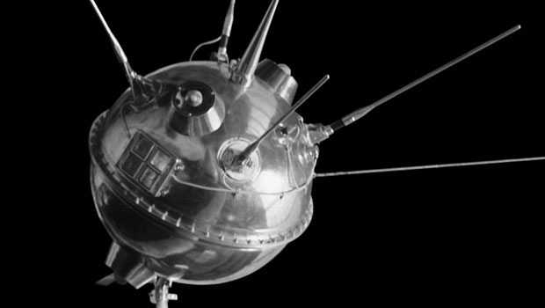
SOURCE: http://www.history.com/news/from-sputnik-to-spacewalking-7-soviet-space-firsts
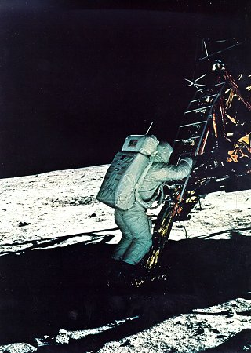
SOURCE: http://history.nasa.gov
Fiscal  Year | Total NASA  Budget (1) | Project  Mercury (2) | Gemini  Program (3) | Apollo Program (4) | Fiscal  Year
1959 | 369 | 46 | 0 | 0 | 1959
1960 | 485 | 84 | 0 | 0 | 1960
1961 | 967 | 124 | 0 | 1 | 1961
1962 | 1,825 | 31 | 55 | 160 | 1962
1963 | 3,674 | 21 | 289 | 617 | 1963
1964 | 5,100 | 0 | 419 | 2,273 | 1964
1965 | 5,250 | 0 | 308 | 2,615 | 1965
1966 | 5,175 | 0 | 197 | 2,967 | 1966
1967 | 4,968 | 0 | 22 | 2,916 | 1967
1968 | 4,589 | 0 | 0 | 2,556 | 1968
1969 | 3,995 | 0 | 0 | 2,025 | 1969
Assessing the funding ranges on the chart, in 1959 the United States would spend $369 million dollars to initiate the space program; however, just a short six years later, the United States would spend an enormous amount of money peaking at $5.25 billion dollars. The ethical monetary question was valid because the United States had other escalating issues that required attention and funding from the government that included: deepening involvement in the Vietnam War, mounting civil rights issues, and of course, the Cold War with the Soviet Union. But, nonetheless, the U. S. space program endured, maintained course, and would emerge victorious in the Space Race.
Conclusion
The Space Race led to major technological advancements. In ten years, the United States would go from not knowing anything about space travel, to creating all the necessary technology, learning about space flight and mastering space travel well enough to take man to the Moon and back. Furthermore, due to the space program’s multitude of successes, spacecraft provided global observations of the Earth, the biosphere, the cryosphere, oceans, atmosphere, and the multiple levels of Earth’s orbit (National Research Council, p. 1). Also, it would be the Space Race itself that would act as the catalyst to the United States’ rising, global power.
Even though the Space Race led to numerous technological advancements inside NASA, the influence of the space program, beyond the scientific, would have far-reaching effects on human behavior, human expression, and human ethics. Human behavior encouraged the many emotions and positive actions associated with the successes of the space program. In human expression, countries around the world would adopt and adapt space themed shows, radio broadcasts, movies, and magazines
into their cultures. In ethics, people would challenge the
potential pitfalls of the Space Race, and weigh them against
the positive aspects of winning the Space Race. The Space
Race era was an amazing time to be alive; the Moon landing
itself was one of the most remarkable events in history. The success of the United States’ greatest adventure would send a tidal wave of happiness, pride, and triumph over the entire country. The monumental achievement, of Americans first step on the lunar surface (above), can be summed up in the great words of the first man to set foot on the Moon, American astronaut Neil Armstrong: “That's one small step for [a] man, and one giant leap for mankind.”
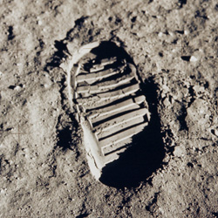
SOURCE: http://www.nasa.gov

References
Andrews, B. (2012). 50 years of Americans in space. (cover story). Astronomy, 40(2),
20.
Burris, A. C. (July 20, 2010). A Brief History of Mathematics Education and the NCTM
Standards. Pearson Allyn Bacon Prentice Hall. Retrieved from
http://www.education. com /reference/article/history-mathematics-education-
NCTM/
Garber, Steve. (October 2007). Sputnik and The Dawn of the Space Age. Retrieved from
http://history.nasa.gov/sputnik/
Green, Nick. (Director). (2008). When We Left Earth: The NASA Missions. United
States: Dangerous Films.
Kranz, Gene. (June 2009). Failure Is Not an Option: Mission Control from Mercury to
Apollo 13 and Beyond. Simon & Schuster.
History. (n.d.). May 25, 1961: JFK asks Congress to support the space program.
Retrieved from http://www.history.com/this-day-in-history/jfk-asks-congress
-to-support-the-space-program
History. (n.d.). The Space Race. Retrieved from http://www.history.com/topics/space-
race
History Shots. (n.d.). Race to the Moon. Retrieved from http://www.historyshots.com/
space/backstory.cfm
John F. Kennedy Presidential Library and Museum. (12/7/11). Address at Rice
University on the Nation's Space Effort, September 12, 1962. Retrieved
from http://classroom.leanderisd.org/users/4297/docs/kennedy_address.pdf
Miller Center. (n.d.). Lyndon Baines Johnson. Retrieved from
http://millercenter.org/president/lbjohnson/essays/biography/print
NASA. (April 2003). Program Overview. Retrieved from http://www-pao.ksc.nasa.gov/
kscpao/history/mercury/mercury.htm
NASA. (October 2007). Kennedy Space Speech Picture. Retrieved from
http://history.nasa.gov
NASA History. (2011). Congressional Digest, 90(7), 196-224.
National Archives. (n.d.). Space Exploration. Retrieved from http://www.archives.gov/
research/alic/reference/space-timeline.html
National Research Council. An Enabling Foundation for NASA's Earth and Space
Science Missions. (2010). Washington, D.C.: National Academies Press.
The Space Race. (n.d.). Timeline of Space Exploration. Retrieved from http://www.the
spacerace.com/timeline/
The Why Files. (n.d.). The U.S. response to Sputnik. Retrieved from http://whyfiles.org/
047sputnik/main2.html
Wagner, M. M. (2002). The Space Race and Biodefense Lessons from NASA about Big
Science and the Role of Medical Informatics. Journal of the American Medical
Informatics Association, 9(2), 120-122.

