Name: Eddie Jackson
Course & Section: BU204 – 02
Unit: 3
Date: June 25, 2012
Question:
The small town of Middling experiences a sudden doubling of the birth rate. After three years, the birth rate returns to normal. Use the graphs for each question, adding any arrows or other indicators that you feel are necessary, to illustrate the effect of these events on the following.

1. What is the effect on the market for an hour of babysitting services in Middling today, during this increased birthrate? Explain the change, if any in the price of babysitting, and in both the amount of babysitting demanded and supplied, giving your reasons for these changes. (10 points)
The effect on the market is as the baby population increases, the demand for baby sitters increase, thus the price for a baby also increases. If we look at the graph, it reflects this. If we look at D1, we can assess that because the baby population was lower, baby sitters were cheaper. However, as the baby population increases to D2, the price also increases due to the scarcity of resources – the baby sitters themselves. You will also notice the point of equilibrium moving up and to the right where D2 intersects S1.

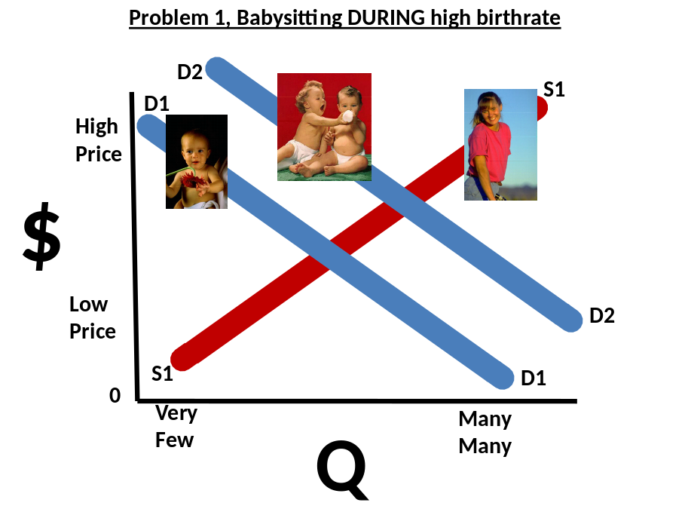

2. What is the effect on the market for an hour of babysitting services 14 years into the future, after the birth rate has returned to normal, by which time children born today, during this increased birthrate, will be old enough to work as babysitters? Explain the change, if any in the price of babysitting, and in both the amount of babysitting demanded and supplied, giving your reasons for these changes. (10 points)
There is the exact opposite effect happening now. Now the baby population is back to normal, however there is a surplus of potential babysitters (from all the babies from #1 that are now teenagers). What this will do to the market is create very competitive prices as the teenagers try to sell their babysitting services. Looking at the graph below, it reflects this. D1 is the babies that need babysitters. S1 was the original amount of potential babysitters, but has moved to S2, which is a significant increase. This should drive down prices as the babysitters compete over the current population of babies. The point of equilibrium actually moves down and to the right on this graph where D1 intersects S2.

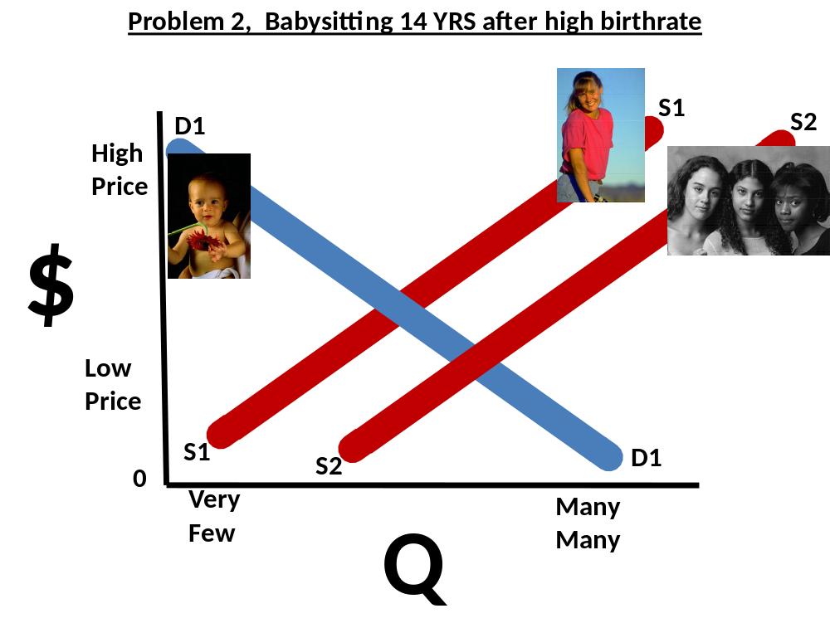

3. What is the effect on the market for an hour of babysitting services 30 years into the future, when children born today, during this increased birthrate, will be adults and are likely to be having children of their own? Explain the change, if any in the price of babysitting, and in both the amount of babysitting demanded and supplied, giving your reasons for these changes. (10 points)
They say history repeats itself, and in this case it’s very well possible. Assuming that many of the original baby boom babies stay in the same area - the women will begin settling in and having families of their own. This will once again cause a rise in the demand for babysitters. Reviewing the graph shows this. D1 represents what a normal baby population looks. But as the baby boom mothers start having children of their own, D1 moves to D2, also known as a “movement”; this causes a rise in prices, and the demand rises (Investopedia). The point of equilibrium once again moves up and to the right where D2 intersects S1.

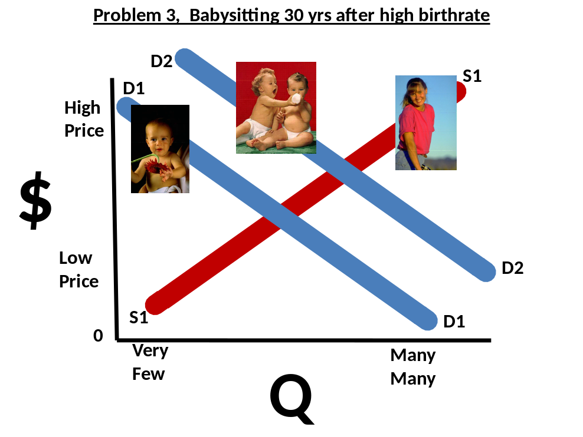

References
Investopedia. (2003). Economics Basics: Demand and Supply. Retrieved on 06/25/2012, from
http://www.investopedia.com/university/economics/economics3.asp/#axzz1yqnOTtgo.

