SDLC & Project Management Life Cycle
Eddie S. Jackson
Kaplan University
IT599: Applied IT Master Project
Rhonda Chicone, Ph.D.
8/4/2015

SDLC & Project Management Life Cycle
SDLC
When installing any IT-based system, there should be a strategic approach taken in the design and implementation of that system. A system could refer to a full-fledged enterprise system, such as an ERP or MIS, a new software application, or even a software or hardware service. Without an official business strategy, there is a good chance that the system will take longer to implement and be riddled with problems all along the way. To reduce problems associated with the setup of a new system, it is common (and best practice) that an IT specialist will use a standardized, proven methodology. One of these methodologies is known as SDLC. SDLC, or systems development life cycle, is a phased approach to system design, which includes three main levels or phases that can be further broken down into eight individual steps (Brown, Dehays, Hoffer, Martin, & Perkins, 2012).
The primary phases of the SDLC are (1) Definition, (2) Construction, and (3) Implementation. In the Definition phase, there are two steps (1) feasibility analysis and requirements definition (Brown, et al., 2012). In the feasibility step, the person leading the systems project will determine the economic, operational, and technical requirements of the system. Of course this person will not work alone; they will meet with a sponsoring manager, the technical people that will be involved with the project, and any other personnel that may have input on the system’s feasibility. The feasibility analysis step is essential to designing and building a new system, in that, this is the step where project leaders and business managers will work together to commit to project resources. The second step in the Definition phase is the requirements definition. In the requirements definition step, an official document is drawn up, known as the system requirements document. In the systems requirement document, there will be detailed descriptions of the new system’s input and output, a refined budget sheet, and an updated plan that will be used for project development.
In the second phase of the SDLC methodology, the Construction phase, there are three separate steps (1) systems design, (2) system building, and (1) system testing (Brown, et al., 2012). The systems design step is just how it sounds; this is where IT specialists design the system, or create a plan for implementing a form of hardware or software. The next step is system building. System building is where the code is developed, the hardware is acquired, or the software is built. Once the system building step is complete, the system will need to be tested. In system testing, the new system is tested in segments, and then in full. The point of this step is for all those involved in the project to sign-off on a “working” system, and for relative documentation to be created.
In the third phase of the SDLC methodology, the Implementation phase, there are three steps (1) installation, (2) operations, and (3) maintenance (Brown, et al., 2012). The installation step is where IT specialists and supporting personnel will begin updating older systems, create databases, prepare the environment for the system, and train employees how to use the new system (if applicable). The second step is operations. In operations, the “system” is close to production; development, test versions, and production versions will be turned over to the proper teams and employees. Documentation will be reviewed, and any updates will be added to this final documentation. If everything is satisfactory, the new system will be deemed acceptable, and closing procedures will be taken to make the new system is fully operational, and considered “in production.” The third and final step in the Implementation phase—as well as in the SDLC methodology—is maintenance. In the maintenance step, when the system needs updates, patches, and upgrades, these tasks must be scheduled, and the changes made accordingly. Likewise, this is the step where improvements can be applied, and user interfaces and user experience can be updated. The maintenance step is an important step in the SDLC methodology, and should be included in the overall business strategy.
Project Management Life Cycle
Of course, as an even better systems management strategy, SDLC may be paired with other best practice management techniques. These techniques could encompass the project life cycle. Understanding the project life cycle will enhance the processes used in the SDLC methodology by adding even more structure to the system design and implementation. The project life cycle is a collection of phases which include initiation, planning, implementation (commonly referred to as execution and control), and closing phases (Watt, 2014). In the Implementation phase, a business case is prepared which includes details such as business need, proposed solutions, and any solutions are reviewed and investigated for viability. The next project life cycle phase is the Planning phase. The Planning phase is where ideas begin to be developed, and the appropriate resources, personnel, and scope are identified. Additionally, tasks and timelines will be discussed, and scheduled will be created. The third phase in the project management life cycle is the Implementation phase. In the Implementation phase, everything comes together; meetings are held, the pieces of the system start to be completed, reporting is done (this includes status reports), and team members work together in testing and implementing the system (pre-production and into production). In the final phase, the Closing phase, the responsibility of the system is transferred to the customer, documentation is handed over, and lessons learned are discussed.
(Watt, 2014)
Synthesis
A best practice approach to implementing a new system is to use SDLC and the project management life cycle. A successful adaption of SDLC and the project life cycle is to first understand how they align. If the phases of each methodology was divided up and matched respectively (using a simple, condensed chart), both approaches could be added to a single project strategy. This can be seen in Figure 1.
■ Figure 1 SDLC and Project Life Cycles
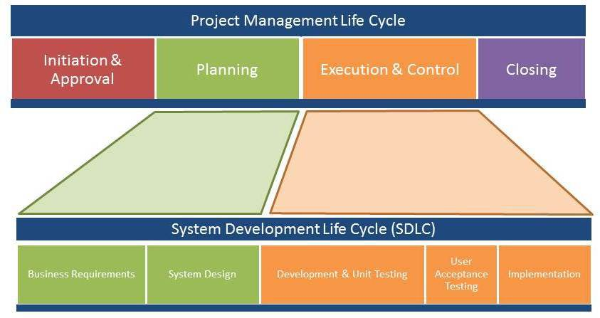
SOURCE: http://www.thinkforachange.com
It is evident, that planning, business requirements, and system design are all closely related. Likewise, execution and control, development, UaT, and implementation can be considered essential to creating the system and then testing a new system.
Real World Example
As a real world example of SDLC and the project management life cycle, a brief scenario has been prepared for review. In this example, a company is rolling out a new enterprise email system. The company is currently using Google’s Gmail, and requires something more robust that does not have restrictions in storage and transmission capabilities. An IT specialist is assigned the project by the CIO, and begins the Initiation and Approval steps, and starts Planning the project. These first steps include holding a few meetings and drafting a project charter. A project charter is an official document that lists details such as project goal, the personnel involved in the project, the stakeholders of the project, and any requirements and constraints that will be essential to the overall project (Rouse, 2012). Additionally, the project charter will discuss milestones and deliverables. Furthermore, business requirements will be considered, such as how many clients need to be upgraded, the cost associated with the project, as well as the scope of the project. These steps are connected to the SDLC Business Requirements and System Design phases, and the Initiation and Planning phases of the project management life cycle.
Referencing the chart in Figure 1, the new email system is to be developed and modular testing is to be performed. The system is installed, sample users are created, and the system is tested in a non-production environment. Once the email system is setup, UaT is completed, and the system is implemented. These steps are part of the Development and Unit Testing, UaT, and Implementation phases in SDLC, and Execution and Control phase in the project management life cycle. The email system is nearly complete, documentation is updated (where applicable), and the administration of the new email system is turned over to the appropriate IT personnel. These steps are linked to the Maintenance phase of SDLC and the Closing phase of the project management life cycle. Note, by this point, the email system is live, the documentation has been completed, personnel have been trained, and the technical administration of the email system has been turned over; lessons learned may be discussed at this time.
Summary
In conclusion, SDLC and the project management life cycle creates a framework which provides structure and organization to a project. SDLC is a phased approach to system design which has three main phases (1) Definition, (2) Construction, and (3) Implementation. The project life cycle also uses three primary phases or stages to organize system design (1) Planning, (2) Implementation, and (3) Closing. The importance of using a methodology cannot be understated nor undervalued; there are numerous advantages, which all lead to the successful implementation of a new system. Thus, learning the utility aspects of SDLC and the project management life cycle will be critical to keeping a project timeline on track, understanding the scope of the project, keeping the project within budget, and maintaining clear lines of communication with all appropriate personnel, including the project’s stakeholders. Thus, applying these methodologies is not only a good idea, it is a necessity.

References

Brown, Dehayes, Hoffer, Martin, & Perkins. (2012). Managing information technology, 7th ed. Prentice Hall, Pearson.
Rouse, Margaret. (2012). Project charter (PC). Retrieved from http://searchcio.techtarget.com/ definition/project-charter-PC
Watt, Adrienne. (2014). The project life cycle (phases). Retrieved from http://opentextbc.ca/ projectmanagement/chapter/chapter-3-the-project-life-cycle-phases-project-management/

