Tilahun Ayanou[21:01 ET]: Recap Unit 1: resource scarcity force to make economic choice
Tilahun Ayanou[21:01 ET]: choices are based opportunity cost: tradeoff
Tilahun Ayanou[21:02 ET]: Unit 2: how to deal with resource scarity
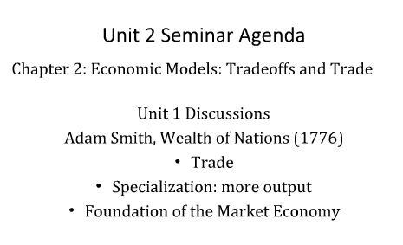
trade leads to specialization
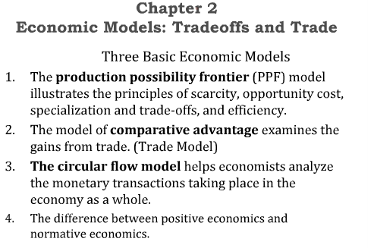
2-deals with area of trade or trade model
Tilahun Ayanou[21:06 ET]: comparative is the basis: domestic + international trade
3-flow model or marketing model, flow of goods and money
Tilahun Ayanou[21:07 ET]: economics agents: firm/business and household/individual
4-positive and normative
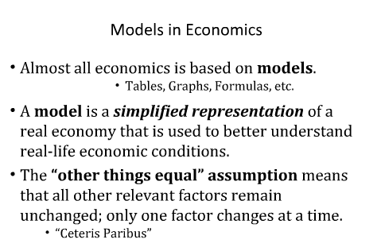
Tilahun Ayanou[21:10 ET]: USA economy: the most complex economy ever
Tilahun Ayanou[21:11 ET]: flow model: business vs house household + role government
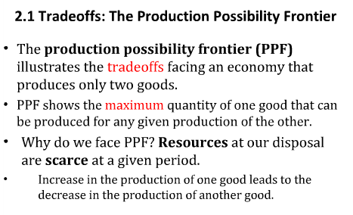
Tilahun Ayanou[21:13 ET]: PPF: capital goods vs consumption goods
Tilahun Ayanou[21:14 ET]: PPF: defense goods vs civilian goods
Tilahun Ayanou[21:16 ET]: economic growth vs equity: distribution
Tilahun Ayanou[21:17 ET]: efficiency vs equity
Tilahun Ayanou[21:22 ET]: specialiation: production (goods + services)
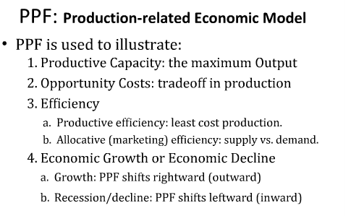
Tilahun Ayanou[21:23 ET]: PPF: applied, it does work
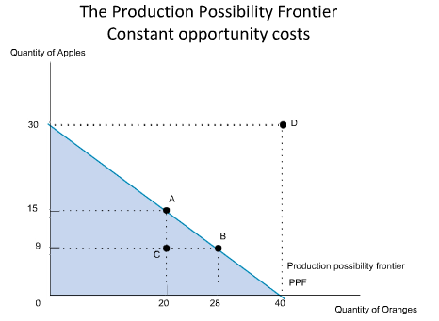
Tilahun Ayanou[21:27 ET]: Combination A (20 oranges, 15 apples)
Tilahun Ayanou[21:28 ET]: B (28 oranges, 9 apples)
Tilahun Ayanou[21:28 ET]: D: outside PPF not possible
Tilahun Ayanou[21:29 ET]: efficient + feasible production: along the PPF (A, B.....)
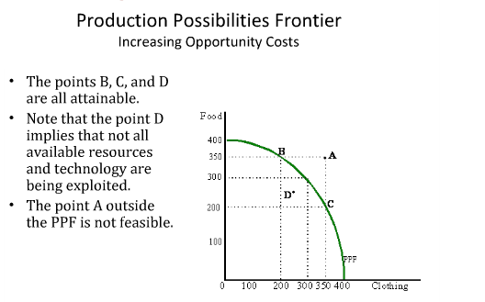
Tilahun Ayanou[21:30 ET]: Tradeoff: opportunity cost
Tilahun Ayanou[21:31 ET]: assignment graph: increase OC
if it outside the PPF it cannot be produced, they don’t have enough resources
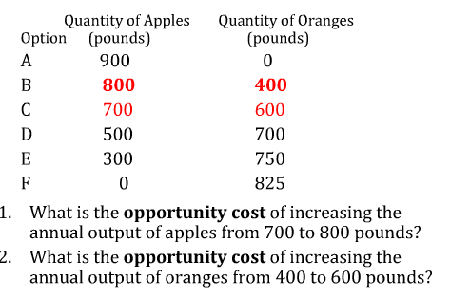
Tilahun Ayanou[21:35 ET]: Anjie: follow this example for the assignment
Tilahun Ayanou[21:38 ET]: if one goods production increases, other goods production decreases
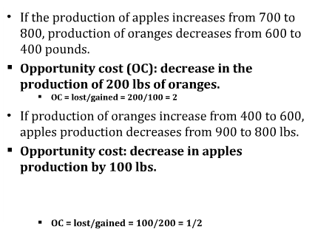
Decrease divided by quantity gained = 200/100 = 2
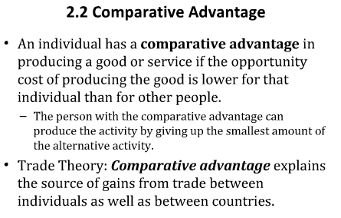
also called trade model
Tilahun Ayanou[21:46 ET]: trade based on lower OC
Tilahun Ayanou[21:47 ET]: problem: cheating in trade: unfair trade practice (currency manipulation: China vs USA)
Explains social gain
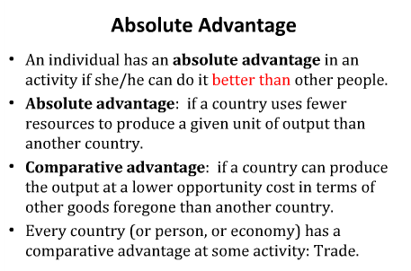
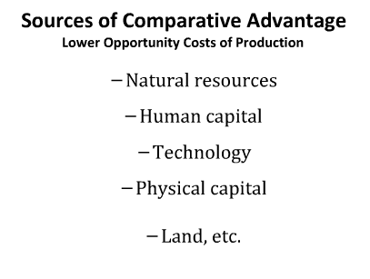
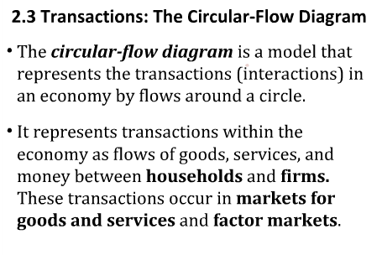
Tilahun Ayanou[21:54 ET]: cost labor is cheap in emerging markets
Anita Bhiro[21:54 ET]: China only allows
Tilahun Ayanou[21:55 ET]: negative trade balance with China
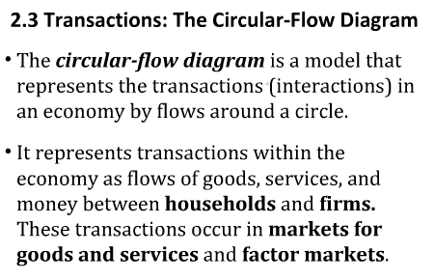
Tilahun Ayanou[21:56 ET]: capital flow is relate to trade balance
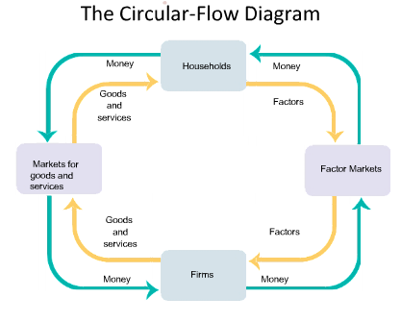
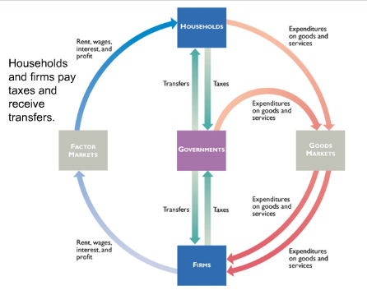
government may intervene with taxation
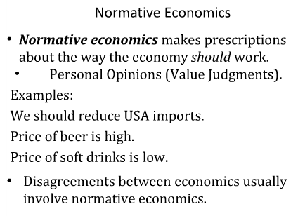
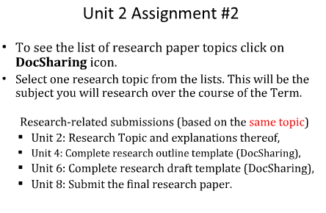
From Chapter 2
A model is a simplified representation of
a real situation that is used to better understand
real-life situations.
The other things equal
assumption means that all other
relevant factors remain unchanged.
The production possibility
frontier illustrates the trade-offs
facing an economy that produces
only two goods. It shows the
maximum quantity of one good
that can be produced for any given
quantity produced of the other.
Factors of production are
resources used to produce goods
and services.
Technology is the technical means
for producing goods and services.
A country has a comparative
advantage in producing a good
or service if its opportunity cost of
producing the good or service is
lower than other countries’. Likewise,
an individual has a comparative
advantage in producing a good or
service if his or her opportunity cost
of producing the good or service is
lower than for other people.
A country has an absolute
advantage in producing a good or
service if the country can produce
more output per worker than other
countries. Likewise, an individual
has an absolute advantage in
producing a good or service if he
or she is better at producing it than
other people. Having an absolute
advantage is not the same thing as
having a comparative advantage.
Trade takes the form of barter when
people directly exchange goods or
services that they have for goods or
services that they want.
The circular-flow diagram
represents the transactions in an
economy by flows around a circle.
A household is a person or a group
of people that share their income.
A firm is an organization that
produces goods and services for sale.
Firms sell goods and services that
they produce to households in
markets for goods and services.
Firms buy the resources they need
to produce goods and services in
factor markets.
An economy’s income distribution
is the way in which total income is
divided among the owners of the
various factors of production.
Most economic models are “thought
experiments” or simplified representations
of reality that rely on the
other things equal assumption.
• The production possibility frontier
model illustrates the concepts of
efficiency, opportunity cost, and
economic growth.
• Every person and every country has
a comparative advantage in something,
giving rise to gains from trade.
Comparative advantage is often confused
with absolute advantage.
• In the simplest economies people
barter rather than transact with
money. The circular-flow diagram
illustrates transactions within the
economy as flows of goods and
services, factors of production, and
money between households and
firms. These transactions occur in
markets for goods and services
and factor markets. Ultimately,
factor markets determine the economy’s
income distribution.
Positive economics is the branch
of economic analysis that describes
the way the economy actually works.
Normative economics makes
prescriptions about the way the
economy should work.
A forecast is a simple prediction of
the future.
Positive economics—the focus
of most economic research—is
the analysis of the way the world
works, in which there are definite
right and wrong answers. If often
involves making forecasts. But
in normative economics, which
makes prescriptions about how
things ought to be, there are often
no right answers and only value
judgments.
• Economists do disagree—though
not as much as legend has it—for
two main reasons. One, they may
disagree about which simplifications
to make in a model. Two,
economists may disagree—like
everyone else—about values.
1. Almost all economics is based on models, “thought
experiments” or simplified versions of reality, many
of which use mathematical tools such as graphs. An
important assumption in economic models is the
other things equal assumption, which allows analysis
of the effect of a change in one factor by holding all
other relevant factors unchanged.
2. One important economic model is the production
possibility frontier. It illustrates opportunity cost
(showing how much less of one good can be produced
if more of the other good is produced); efficiency (an
economy is efficient in production if it produces on the
production possibility frontier and efficient in allocation
if it produces the mix of goods and services that
people want to consume); and economic growth (an
outward shift of the production possibility frontier).
There are two basic sources of growth: an increase in
factors of production—resources such as land, labor,
capital, and human capital, inputs that are not used up
in production—and improved technology.
3. Another important model is comparative advantage,
which explains the source of gains from trade between
individuals and countries. Everyone has a comparative
advantage in something—some good or service in
which that person has a lower opportunity cost than
everyone else. But it is often confused with absolute
advantage, an ability to produce a particular good or
service better than anyone else. This confusion leads
some to erroneously conclude that there are no gains
from trade between people or countries.
4. In the simplest economies people barter—trade goods
and services for one another—rather than trade them
for money, as in a modern economy. The circular flow
diagram represents transactions within the
economy as flows of goods, services, and money
between households and firms. These transactions
occur in markets for goods and services and factor
markets, markets for factors of production—land,
labor, physical capital, and human capital. It is useful
in understanding how spending, production, employment,
income, and growth are related in the economy.
Ultimately, factor markets determine the economy’s
income distribution, how an economy’s total income
is allocated to the owners of the factors of production.
5. Economists use economic models for both positive
economics, which describes how the economy works,
and for normative economics, which prescribes how
the economy should work. Positive economics often
involves making forecasts. Economists can determine
correct answers for positive questions but typically
not for normative questions, which involve value judgments.
The exceptions are when policies designed to
achieve a certain objective can be clearly ranked in
terms of efficiency.
6. There are two main reasons economists disagree. One,
they may disagree about which simplifications to make
in a model. Two, economists may disagree—like everyone
else—about values.

