My Notes  
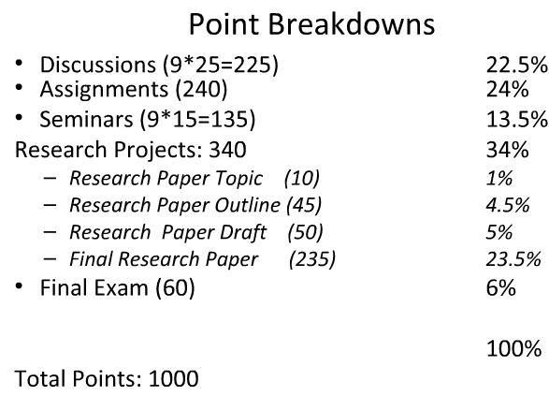  
  
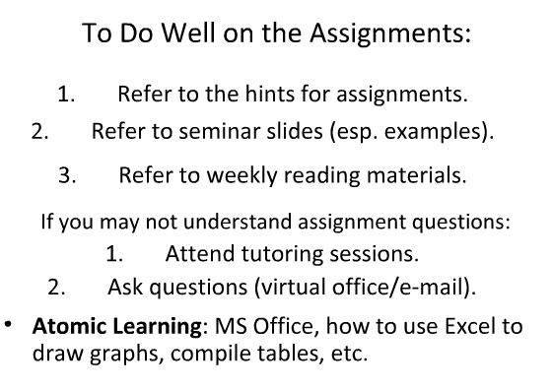  
  
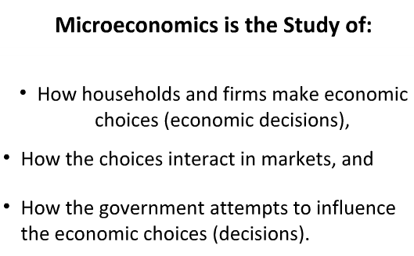  
  
  
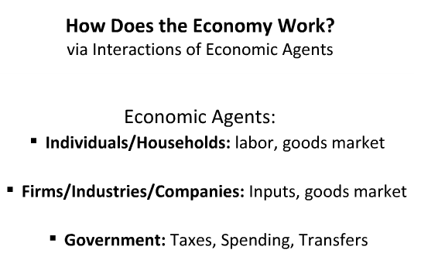  
  


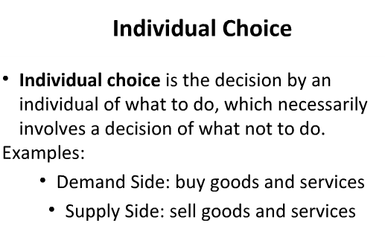  
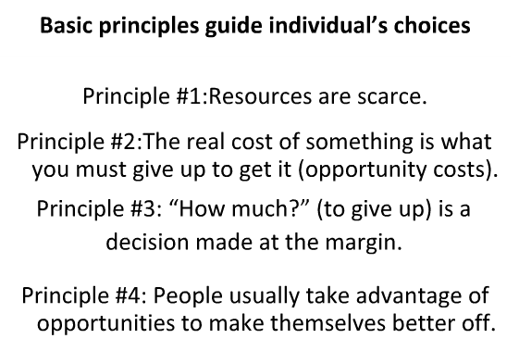  
Tilahun Ayanou[21:22 ET]: economics cost : opportunity cost

Tilahun Ayanou[21:23 ET]: accounting cost" money

Tilahun Ayanou[21:24 ET]: #4 low tax rate

Tilahun Ayanou[21:24 ET]: Incentives  
  
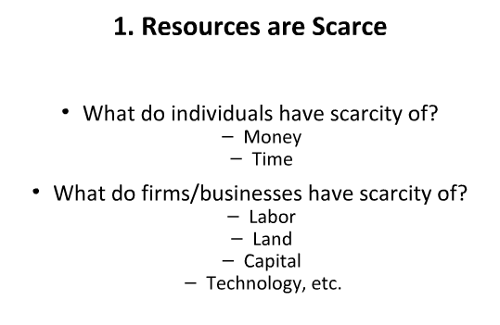  
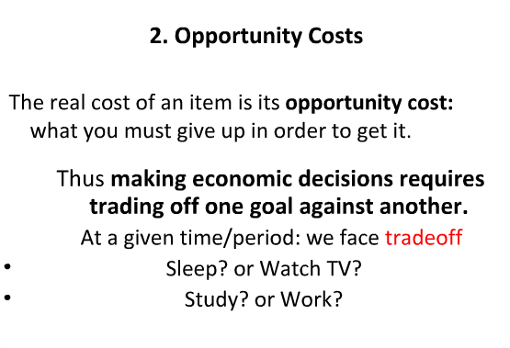  
  
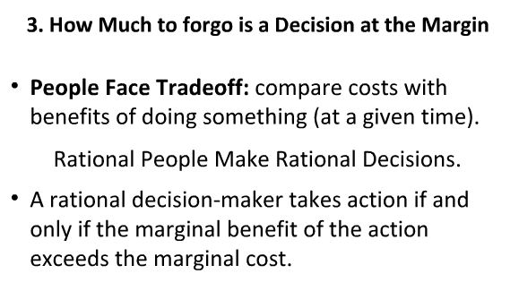  
Tilahun Ayanou[21:32 ET]: people don’t waste resources

Tilahun Ayanou[21:33 ET]: marginal: additional  
  
