SparkNotes Microeconomics
Introduction

Economics
- Economics is the study of how limited resources are allocated.
- There are two main branches of economics:
  - Microeconomics studies how individuals (firms or households) make choices and are influenced by economic forces.
  - Macroeconomics looks at the economy as a whole, focusing on issues such as growth, unemployment, inflation, and business cycles.

Economics Reasoning
- Given limited resources (scarcity), there are opportunity costs for every choice.
- The opportunity cost of an action is the benefit missed by not choosing the next-best alternative. An action should be chosen only if the expected benefit is greater than the opportunity cost.
- Individuals attempt to maximize their utility by allocating and spending their resources according to their preferences.
- Individual consumption and production options are expanded through the market, where goods and services are exchanged for mutual benefit.

Demand and Supply

Demand
- Demand is the relationship between the price of a good and the quantity of it that consumers are willing to buy at that price.
- Demand curve: A graphical representation of the law of demand. It slopes downward (for most goods) because, all else constant, the quantity demanded rises (falls) as the price falls (rises).
  - A change in price is represented by movements along the demand curve; demand is still the same, but the quantity demanded changes as the price changes.
  - The demand curve will shift to the left or right when anything other than the price of the good has changed.
  - The market demand curve is the horizontal sum of all individual demand curves.
- Changes in price also affect the demand for related goods.
  - Substitutes: Goods that can be used in place of another good. If the price of a good rises (falls), the demand for its substitute goods will rise (fall).
Example: Coke® and Pepsi®.
  - Complements: Goods that are normally used in conjunction with another good. If the price of a good rises (falls), the demand for its complement goods will fall (rise).
Example: Left shoes and right shoes.
- The relationship between demand and price is caused by two main effects:
  - Income effect: A change in price affects overall purchase power.
  - Substitution effect: A change in price affects not only the absolute price of the good but also the relative price of the good, leading to changes in the purchasing of substitute goods.
- The effects are different for different types of goods:
  - Normal goods: When income rises (falls), demand increases (decreases). Most goods are normal.
  - Inferior goods: When income rises (falls), demand decreases (increases), because better goods can be afforded.
Example: Generic-label foods.
  - Giffen goods: Quantity demanded rises (falls) as the price rises (falls). Giffen goods are inferior goods with strong income effects.
Example: Potatoes during the Irish Potato Famine.
  - Veblen goods (or snob goods): Quantity demanded rises (falls) as price rises (falls) because the goods are purchased to demonstrate one’s wealth to others. Also known as conspicuous consumption.
Example: Designer-label clothing.
- relationship between the price of a good and the quantity of it that firms are willing to produce at that price.
- Supply curve: A graphical representation of the law of supply. It slopes upward because quantity supplied rises as price rises, with other things constant.
  - A change in price is represented by movements along the supply curve; supply is still the same, but the quantity supplied changes as the price changes.
  - The supply curve will shift to the left or right when anything other than the price of the good has changed. Such factors include: changes in prices of inputs used in production, changes in technology, changes in supplier expectations about future prices, changes in taxes and subsidies.
  - The market supply curve is the horizontal sum of all individual supply curves.

Utility Maximization
- The budget constraint intersects many indifference curves but the best combination of goods is on the highest possible indifference curve, where the budget constraint is tangent to the indifference curve.
- When utility is maximized, the ratio of the two goods’ marginal utilities will equal the ratio of the two goods’ prices.
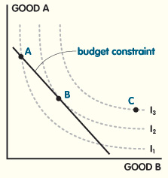
Utility Maximization
FIGURE 2 Point A is within the budget constraint but is on a lower indifference curve than point B, which is the utility maximization point. Point C is on a more desirable indifference curve but is not a possible choice because it is outside the budget constraint.

Elasticity
- Elasticity measures the sensitivity between two economic variables.
- Measuring elasticities is important because it allows individuals, firms, and societies to estimate the impacts that economic decisions will have.

Demand Elasticity
Price Elasticity of Demand
- The price elasticity of demand (PED) measures how much a change in the price of a good affects the quantity demanded.
- PED = (% change in quantity demanded) / (% change in price).
  - If the PED is greater than 1, the demand is elastic.
  - If the PED is less than 1, the demand is inelastic.
  - If the PED equals 1, the demand is unit elastic.
  - Elasticity determines the shape of the demand curve.
  - The PED is actually negative because the demand curve slopes downward, but economists report it as an absolute value.
- A high (low) PED means that the quantity demanded of a good changes by a lot (a little) when the price changes.
  - If there are substitutes for a product, the PED is higher. For goods that are completely interchangeable with others, such as two different brands of white rice, the demand curve is horizontal and the PED is perfectly elastic.
  - If the product is a necessity or has few substitutes, such as water, the PED is lower. For absolute necessities with no substitutes, such as insulin for a diabetic, the demand curve is vertical and the PED is perfectly inelastic.
  - Long-run elasticity is higher than short-run elasticity because individuals are able to make more adjustments in the long run.
- Because there are two different opposite effects on revenue when the price changes (quantity also changes), the PED also determines how changes in price will affect revenue.
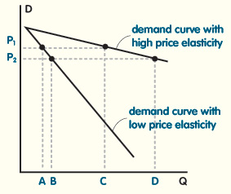
Price Elasticity of Demand
FIGURE 3 For the same change in price, the quantity demanded for the low-elasticity demand curve moves only from Point A to Point B, while the quantity demanded for the high-elasticity demand curve moves a much larger distance, from Point C to Point D.
- If demand is elastic, the quantity demanded will rise (fall) by a greater percent than the price falls (rises). Revenue will increase (decrease).
- If demand is inelastic, the quantity demanded will rise (fall) by a lesser percent than the price falls (rises). Revenue will decrease (increase).
- If demand is unit elastic, the quantity demanded will rise (fall) by the same percent that the price falls (rises). Revenue will stay the same.
Income Elasticity of Demand
- The income elasticity of demand (IED) measures how much a change in income affects the quantity demanded.
- IED = (% change in quantity demanded) / (% change in income).
- IED is reported as a negative number for inferior goods because a change in income causes an opposite change in demand.

Firm Behavior

Perfect Competition
- The following conditions are true for a perfectly competitive market:
  - A product sold by multiple firms is essentially the same.
  - There is a large number of firms and consumers so none can individually influence the market.
  - There are few or no barriers to entry into the market.
  - Each firm is a price taker, meaning that the price they charge is determined by the market.
  - Consumers and firms have perfect information, meaning that they are aware of all other products and firms in the market.

Maximization Framework
- Firms produce goods and services with the assumed goal of maximizing profits.
- Each firm has a supply function (supply curve) illustrating how much will be produced by the firm at various price levels in order to maximize profits.
- Profits: Total revenue minus total costs.
  - Economic profits: Total costs include opportunity costs.
  - Accounting profits: Total costs exclude opportunity costs.
Revenue
- Total revenue (TR): (Price per unit) times (quantity sold).
- Average revenue (AR): Total revenue divided by the number of goods sold.
- Marginal revenue (MR): Revenue received for the last good sold.
- Because markets are competitive, average and marginal revenues for each firm should be equal to the market price of the good.
Costs
- Total costs: variable costs plus fixed costs.
  - Total variable costs (TVC): Costs that are dependent upon the quantity produced (such as labor).
  - Total fixed costs (TFC): Costs that are independent of the quantity produced (such as land).
- Average total, variable, and fixed costs (ATC, AVC, and AFC): total, variable, or fixed costs divided by the number of goods produced.
- Marginal cost (MC): The cost to make one additional unit.
- Sunk costs: Costs that cannot be recovered.
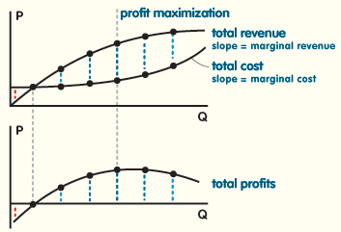
Profit Maximization
FIGURE 4 Profit is maximized where the slope of the total revenue curve (marginal revenue) equals the slope of the total cost curve (marginal cost).
Production Function
- The production function is shown as a curve and illustrates how much can be produced for different amounts of inputs.
- Two inputs are used in the production of goods, capital (K) and labor (L): Q=f(K, L).
- Average product (AP): Total product / quantity produced.
- Marginal product (MP): The change in output due to a unit increase in input.
- To maximize profits, the quantity produced by a firm should be such that MC is equal to MR. In a competitive market, this means that MR and MC will equal price.

Short Run
- Short run: the time frame in which fixed costs are not changeable.
- In the short run, K is usually fixed, so the production function will reflect how the quantity produced changes as the labor input changes.
- Returns to labor:
  - Increasing returns to labor: MP increases and MC decreases as more labor is added.
  - Decreasing returns to labor: MP decreases and MC increases as more labor is added.
- Relationships between the short-run cost curves:
  - When ATC and AVC are falling (rising), MC is lower (higher). This means that the MC curve will intersect the ATC and AVC curves at their lowest points.
  - As the quantity produced increases, fixed costs become a smaller percentage of total costs. This means that the distance between the ATC and AVC curves will get smaller as more is produced.
  - Because firms produce at a quantity where marginal cost equals market price, it is possible to represent a firm’s profit at any given price on the cost curves.
- If price were set to where the MC curve and ATC curve intersect, the firm would break even.
- If price were set below the ATC curve, the firm would have a loss.
- If price is set at or below the minimum point of the AVC curve, the firm should shut down.
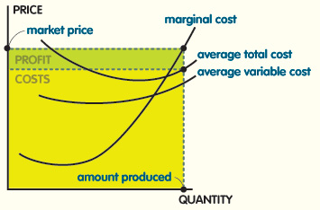
Illustration of Cost Curves
FIGURE 5 Profit is the difference between total revenue (amount produced × market price) and total costs (amount produced × average total cost).

Long Run
- Long run: the amount of time where fixed costs are able to change.
- All inputs are variable in the long run, so there are many possible combinations of K and L. Plotting these combinations on a graph results in an isoquant. There are different levels of isoquants for different levels of production.
  - Marginal rate of technical substitution (MRTS): Along the isoquant, it is possible to exchange one input for another and remain at the same output level. The exchange rate is the MRTS, which is equal to change in K divided by change in L.
- The firm’s cost of production is based upon the prices of its inputs. The firm always tries to minimize total costs for a given level of production. All possible combinations of K and L for each cost level are illustrated in isocost lines.
- Cost is minimized at the point where the isoquant is tangent to the isocost line.
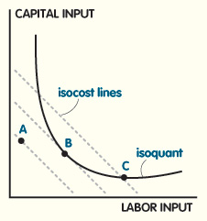
Long-Run Profit Maximization
FIGURE 6 Point A would not allow the firm to produce at the selected level (isoquant). Point C is at the appropriate level of production, but it is not the lowest possible cost for that level. Cost is minimized at Point B, where the isoquant is tangent to the isocost line.
Average Cost and Returns to Scale
- Economies of scale (increasing returns to scale): Long-run ATC decreases as output increases.
- Diseconomies of scale (decreasing returns to scale): Long-run ATC increases as output increases.
- Constant returns to scale: Long-run ATC stays the same as output increases.
- Most firms begin their growth with economies of scale, then have a period of constant returns to scale, then reach a point where they have diseconomies of scale.
- Minimum efficient scale: Point of lowest production where ATC is at a minimum.
- In the long run, a firm is able to expand, which will shift its ATC out. Each production option has its own ATC. Combined, the minimum points of the various ATCs will create the long-run ATC.
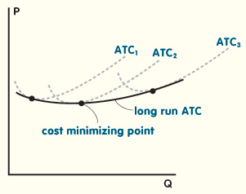
Long-Run Cost Minimization
FIGURE 7 The minimum point on the long-run ATC is the long-run cost minimizing point of production.
Long-Run Market Equilibrium
- For individual firms, demand is set at a constant price because they cannot affect it. So, though the market demand curve may be downward sloping, the demand curve from the firm’s perspective is flat.
- When the market is in equilibrium, the market price is equal to the profit-maximizing price of the individual firm. Profits are zero so no firms are leaving or entering the market.
  - If the market demand increases (decreases), the price will rise (fall) in the short term.
  - The higher (lower) price will increase (decrease) profits for the firm.
  - Increased (decreased) profits will lead more firms to enter (leave) the market, increasing (decreasing) the market supply.
  - This will push the price back down (up) to where profits for the firm are zero and the market is in equilibrium.
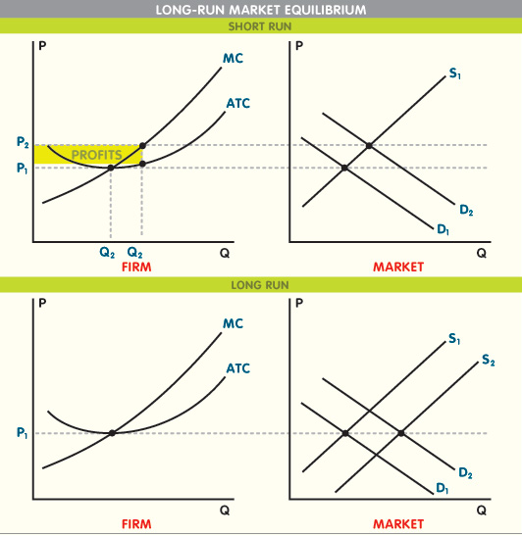
Long-Run Market Equilibrium

Labor Market
- Labor is treated like any other good in the market, except demand comes from the firm instead of the consumer.
- The price a firm pays for labor is known as the wage. In addition to a wage, workers also commonly receive fringe benefits such as insurance and vacation time.
  - Real wage: Wage adjusted for inflation.

Demand
- The demand curve for the labor market shows how much labor firms will buy at each wage.
- Firms must determine how much labor is needed for a profit-maximizing level of production.
- Marginal revenue product (MRP): Revenue increase resulting from the purchase of an additional unit of labor.
  - The firm maximizes profits by purchasing additional labor until the MRP is equal to the market wage.
  - If the costs of any factors necessary to produce a good change, the MRP will be affected and the amount of labor demanded by the firm will also change.
- Adding up all the firms’ labor demand curves will equal the market labor demand curve.
- If demand increases (decreases) for a good that a particular type of labor produces, the demand for that type of labor will also increase (decrease).
- households will provide at each wage.
- There are two alternatives for each household’s time: leisure and working at home.
- As the market wage changes, decisions concerning work will also change. There are two effects of a wage change, which work in opposite directions:
  - Substitution effect: If the marginal benefit of leisure or working at home is higher than the market wage, the household should choose either leisure or working at home. This means that as the wage rises (falls), households are more (less) likely to choose the labor market.
  - Income effect: As the wage rises (falls), households are less (more) likely to spend more time in labor market. With a higher (lower) wage, they can work less (more) to make the same income.
- The relative strengths of the income and substitution effects will determine the shape of the household’s labor supply curve.
  - If the substitution effect is stronger, the curve will be upward sloping.
  - If the income effect is stronger, the curve will be downward sloping.
  - If the substitution and income effects are equal, the curve will be vertical.
- Most people have a backward-bending labor supply curve, which is upward sloping for low wages, vertical or nearly vertical at higher wages, and bends backward with a downward slope for the highest wages.
- Market labor supply, on the other hand, is a straight, upward sloping line. It is not backward-bending because, as a whole, more workers will be attracted to higher-paying jobs.
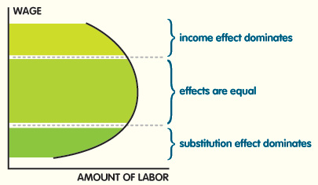
Backward-Bending Labor Supply

Equilibrium
- As with other goods, the supply and demand for labor create an equilibrium wage rate and quantity in the market when they are equal.
- There are several possible inefficiencies, which may cause the wage to differ from equilibrium:
  - Income tax: Workers pay a tax on their income, and it affects the amount of time they are willing to work.
  - Minimum wage: The government sets in the market a minimum wage, which firms are forced to pay.
    - If the minimum wage is lower than the market equilibrium wage, then there is no impact because firms will pay the equilibrium wage.
    - If the minimum wage is higher than the market equilibrium wage, labor supplied will be higher than labor demanded, and some workers will be unable to find jobs.
  - Discrimination: Firms may choose to hire or set wages based on factors that are not related to productivity, such as race, age, or gender. Nonprofit maximizing decisions are inefficient.
  - Unions By bargaining with firms for higher wages, unions decrease demand for labor. Some workers will then move to nonunion firms, which can compete with lower costs because they pay lower wages. However, union firms often have other benefits that offset the higher cost of labor, such as lower turnover.

Public Welfare

Income Equality
- The closer individual incomes are, the more equal the distribution. The more varied individual incomes are, the more unequal the distribution.
- There are a few ways to measure how equal income distribution is:
  - Income segments: Determine how one market group relates to another by comparing the percentage of total income (the sum of all incomes) held by each group.
  - Lorenz curve: Shows the income distribution based on the cumulative percentages of income earned by percentage of the population. The curve is compared to a perfectly equal distribution (a straight line).
  - Gini coefficient: Shows income distribution as a value between 1 (perfectly unequal) and 0 (perfectly equal). It is calculated by dividing the area between the perfectly equal distribution and the Lorenz curve by the total area between the perfectly equal and perfectly unequal distribution lines.

Government Intervention in the Market
- Often governments create programs to change the income distribution.
  - Subsidies: A low-income group receives money (or vouchers) for specified goods.
  - Progressive taxes: Rich people are taxed at higher rates than poor people. Some of the money is then used to create programs to help the poor.
  - Welfare: Low-income families receive cash and decide what goods they need.
  - Unemployment benefits: Monetary benefits for those unable to find work.
  - Price ceiling: To protect the poor, a product’s highest possible price is set, so the price is lower than equilibrium and more will be demanded than supplied.
  - Price floor: To protect producers, a product’s lowest possible price is set, so the price is higher than equilibrium and more will be supplied than demanded.

Market Inefficiency

Inefficiency
- Pareto efficiency: In an efficient market, there are no possible trades that will make one party better off without making another party worse off.
- A pareto efficient market requires:
  - Every producer of a good should have the same marginal costs.
  - For each item produced, marginal cost should equal marginal benefit.
  - All consumers should receive the same marginal benefit from the same good.
- In a competitive market, it is assumed that the market equilibrium is pareto efficient.

Deadweight Loss
- Deadweight loss is a cost to society caused by government programs, externalities, monopolies, or other market inefficiencies. Policy-makers must weight the benefits of each government program against its costs.
- If the level of production in a market is inefficient, there will be a deadweight loss to the society of the producer and consumer surplus.
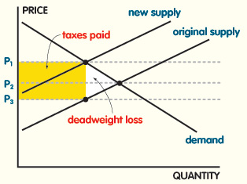
Deadweight Loss from Taxes
FIGURE 10 Sales tax raises the marginal cost of producing the goods being taxed, shifting the supply curve up by the amount of the tax. The equilibrium price rises less than the amount of the tax, so even though the rectangular part indicated goes to the government, there is still a deadweight loss.

Other Barriers to Efficiency
- Self-interest: Economics often assumes that individuals always act in their self-interest, but some people are altruistic and derive pleasure from helping others.
- Nonrational: Economics assumes that people behave rationally, but realistically, all the requirements of the economic model will not be met when making decisions.
- Sunk costs: Sunk costs should not be considered in decision-making, but most people consider them because they feel as though something is being lost. Money makes people act in ways that are inconsistent with the economic model.
- Uncertainty: Economics assumes there is perfect information in the market, but this is rarely the case, and choices must often be made with limited information.
- Asymmetric information: Different people have access to different information about the market.
- Moral hazard: People are less careful if they have insurance.
- Adverse selection: People who have insurance have the highest risks in the population.

Public Goods and Externalities
Public Goods
- Public goods have two distinct properties and one attendant problem:
  - Nonrivaly: One person’s increased consumption of the good does not decrease the amount of the good available to others.
  - Nonexcludability: It is not possible to keep some people from consuming the good.
  - Free-rider problem: A person cannot be kept from consuming the good even if they don’t contribute to the costs (example: people who don’t pay their taxes still benefit from national defense).
Externalities
- Negative externalities occur when the costs of producing or consuming a good affect those who are not involved (example: pollution).
  - Production level is higher than efficient because the marginal private cost, which the firm uses to make the production decision, is lower than the marginal social cost, which is the actual cost as it affects society.
  - Firms produce too much and create a deadweight loss for society. Government usually intervenes to make sure not too much of the good is produced.
- Positive externalities occur when the benefits of producing or consuming a good affect those who are not involved (example: a safer neighborhood from one household’s purchase of private security).
  - Consumption is lower than efficient because the marginal private benefit, which consumers use to make the consumption decision, is lower than the marginal social benefit, which is the actual cost as it affects society.
  - Consumers buy too little and create a deadweight loss for society. Government usually intervenes to make sure enough of the good is produced.

Imperfect Competition
Oligopoly
- Oligopoly: Small number of firms, some barriers to entry, unique products.
  - Duopoly is a special oligopoly with only two firms producing a good.
- Oligopolies are inefficient because they can create monopoly-like markets through collusion.
  - Explicit collusion: Firms openly work together to make pricing or production decisions.
  - Tacit collusion: Firms implicitly work together to make pricing or production decisions.
  - Cartel: A combination of firms in the same market that work together to make pricing or production decisions.
  - Collusion is illegal in the United States.

Monopoly
- Monopoly: One firm, extreme barriers to entry, unique product.
- Monopolistic competition: Large number of firms, low barriers to entry, unique products.
- There are several possible reasons for a monopoly to occur:
  - Exclusive control: Only one firm has access to the inputs needed to make the product.
  - Natural monopoly: Because of economies of scale, the market may be best served by having only one firm because production costs increase when there are more firms.
  - Patents and licenses: Inventions are patented so that others can’t produce the same thing, and licenses are given that limit the use of a particular resource or area.
- Unlike a competitive firm, a monopoly’s MR does not equal the price of the market. They are two separate values at any given price level.
- For a monopoly, MC = market supply.
- Because there is no market competition, a monopoly can maintain profit levels by controlling supply at the level where MC = MR, thus controlling the price.
- If the firm remains a monopoly, it can continue to make profits indefinitely.
- Monopolies sometimes lose money in the short term, usually when they have up-front research or patent costs to incur.
- As with a competitive firm, a monopolist should shut down if AVC is larger than the price.
- Efficiency is lost with a monopoly because the consumer loses the surplus that would occur in perfect competition. The producer (monopoly) gains a part of what would have been the consumer surplus. The remainder becomes deadweight loss.
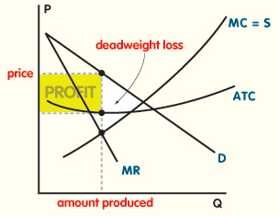
Monopoly Profit Maximization
FIGURE 11 The minimum point on the long-run ATC is the long-run cost minimizing point of production.

Government Regulation
- Most government in capitalist countries set policies and regulations to prevent the occurrence of monopolies or any type of collusion that would be harmful to competition.
- In the United States, these policies are called anti-trust policies. The major antitrust laws in the United States include:
  - Sherman Anti-Trust Act (1890): Made price fixing and attempting to monopolize illegal.
  - Clayton Anti-Trust Act (1914): Tried to keep monopolies from being created through mergers.
  - Federal Trade Commission (FTC) Act (1914): Set up the FTC to enforce the Sherman and Clayton acts.

