Key
done - 1. * hint use stat crunch
Using the MM207 Student Data Set:
a) What is the correlation between student cumulative GPA and the number of hours spent on school work each week? Be sure to include the computations or StatCrunch output to support your answer.
My answer (from StatCrunch):
Correlation between Q10 What is your cumulative Grade Point Average at Kaplan University? and Q11 How many hours do you spend on school work each week? is:
0.27817234
b) Is the correlation what you expected?
My answer: No. I expected the correlation to be much higher because the more hours you study should equate to a much higher GPA – in theory that is.

c) Does the number of hours spent on school work have a causal relationship with the GPA?
My answer: Yes. I was going to say no (because of the low correlation above), until I did a scatter plot. This shows that there definitely is a casual relationship between study time and GPA.
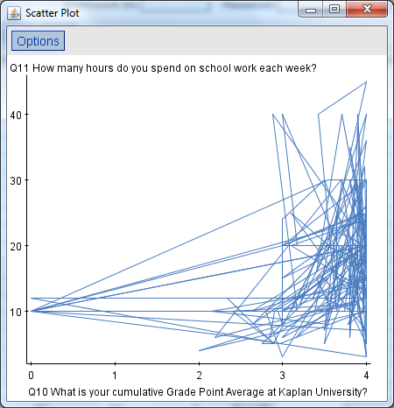

d) What would be the predicted GPA for a student who spends 16 hours per week on school work? Be sure to include the computations or StatCrunch output to support your prediction.
My answer: 3.6
from StatCrunch
Group by: Q11 How many hours do you spend on school work each week?
Q11 How many hours do you spend on school work each week? | Mean | n | Variance
3 | 3.6666667 | 3 | 0.33333334
4 | 2 | 1 | NaN
5 | 3.3775 | 8 | 0.3129357
6 | 3.0714285 | 7 | 0.42641428
7 | 3.75 | 2 | 0.125
8 | 3.352 | 5 | 0.26252
10 | 2.9693334 | 30 | 1.6706271
11 | 3.6466668 | 3 | 0.14423333
12 | 3.290909 | 11 | 1.4214091
13 | 4 | 2 | 0
14 | 3.93 | 2 | 0.0098
15 | 3.7127273 | 11 | 0.11040182
16 hours | 3.6 | 3 | 0.07

- done - 2.
Select a continuous variable that you suspect would not follow a normal distribution.
My answer: my continuous variable is “Age”
- Create a graph for the variable you have selected to show its distribution.
My answer:
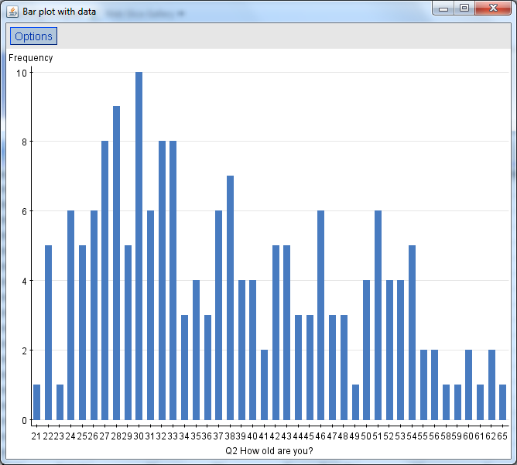
- Explain why these data might not be normally distributed.
My answer: These may not be normally distributed due to the fact that people of all ages go to school – you will notice that all values are not tightly gathered around the mean.
- Select a second continuous variable that you believe would approximate a normal distribution
My answer: my continuous variable is “Height”
- Create a graph to show its distribution.
My answer:
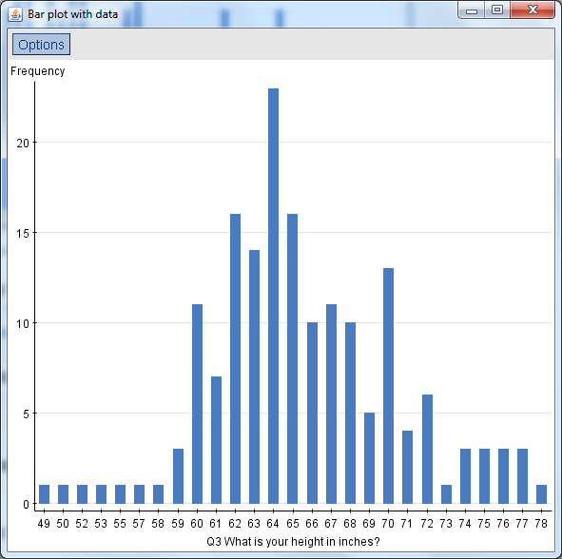
- Explain why these data might be normally distributed.
My answer: People are different heights of course, however you see an obvious tighter grouping around the mean; suggesting these values are closer to a normal distribution.

done - 3. * hint Statcrunch->Summary Stat->columns. Select Q2 and in group by select Gender.
Jonathan is a 42 year old male student and Mary is a 37 year old female student thinking about taking this class. Based on their relative position, which student would be farther away from the average age of their gender group based on this sample of MM207 students?
My answer: Jonathan
from StatCrunch
Summary statistics for Q2 How old are you?:
Group by: Gender
Gender | n | Mean | Variance | Std. Dev. | Std. Err. | Median | Range | Min | Max | Q1 | Q3
Female | 138 | 37.746376 | 104.015495 | 10.198799 | 0.86817944 | 37 | 44 | 21 | 65 | 30 | 46
Male | 35 | 38.8 | 160.28235 | 12.660267 | 2.1399755 | 35 | 38 | 24 | 62 | 28 | 51

done - 4.* hint manual calculation, don’t over think, standard probability, count things up, get your total
4. If you were to randomly select a student from the set of students who have completed the survey, what is the probability that you would select a male? Explain your answer.
My answer: 0.2
35 males+138 females+2 no gender listed=175 students total
That makes the probability equal to
35 males/175 total students or 35/175 = 0.2
Calculations
Calculator says 0.2
Turn that into a percent = 20%
from StatCrunch
Frequency table results for Gender: = 173 count + 2 that did not list gender = 175 students total
Group By: Gender
Results for Gender=Female
Gender | Frequency | Relative Frequency
Female | 138 | 1
Results for Gender=Male
Gender | Frequency | Relative Frequency
Male | 35 | 1

done - 5. Don’t over think
a. * hint For 5a and 5b use Stat->Table->contingency->with data. Row and column are as indicated in answer.
b. * hint For 5a and 5b use Stat->Table->contingency->with data. Row and column are as indicated in answer.
Using the sample of MM207 students:
What is the probability of randomly selecting a person who is conservative and then selecting from that group someone who is a nursing major?
My answer:
For conservative it is: 41 conservative/175 total count or 41/175 or 0.2343 or 23% rounded to the nearest percentage
For a nursing major: 12 conservative-nursing students/175 total count = 12/175 or 0.0686 or 7% rounded to the nearest percent.
Calculator says 0.07058823529411764705882352941176
from StatCrunch
Frequency table results for Q13 What best describes your political philosophy?: = 170+5 who did not answer = 175 total count
Q13 What best describes your political philosophy? | Frequency
Conservative | 41
Liberal | 40
Moderate | 89

Contingency table results for Q13 What best describes your political philosophy?=Conservative:
Rows: Q13 What best describes your political philosophy?
Columns: Q9 What is your college major?
 | Business | IT | Legal Studies | Nursing | Other | Psychology | Total
Conservative | 4 | 1 | 5 | 12 | 4 | 14 | 40
Liberal | 0 | 0 | 0 | 0 | 0 | 0 | 0
Moderate | 0 | 0 | 0 | 0 | 0 | 0 | 0
Total | 4 | 1 | 5 | 12 | 4 | 14 | 40

- What is the probability of randomly selecting a liberal or a male?
My answer:
0.3886
175 total count
For a liberal it is: 23.81% or 40/168 (includes males and females)
For a male who is either liberal/moderate/conservative = 35/168 or 20.83%
Minus those that are Male AND Liberal -7
Make sure to count all students in survey 175
So that would be 40+35-7 = 68/175 = 0.3886
Or the 168 students who answered the question
For a liberal it is: 23.81% or 40/168 (includes males and females)
For a male who is either liberal/moderate/conservative = 35/168 or 20.83%
Minus those that are Male AND Liberal -7
Add those together
So that would be 40+35-7 = 68/168 = 0.4047619047619047619047619047619
Contingency table results:
Rows: Q13 What best describes your political philosophy?
Columns: Gender
Cell format
Count
(Row percent)
(Column percent)

 | Female | Male | Total
Conservative | 27  (67.5%)  (20.3%) | Add 13  (32.5%)  (37.14%) | 40  (100.00%)  (23.81%)
Liberal | 33  (82.5%)  (24.81%) | Subtract 7  (17.5%)  (20%) | Total liberals 40  (100.00%)  (23.81%)
Moderate | 73  (82.95%)  (54.89%) | Add 15  (17.05%)  (42.86%) | 88  (100.00%)  (52.38%)
Total | 133  (79.17%)  (100.00%) | 35  (20.83%)  (100.00%) | 168 total  (100.00%)  (100.00%)

done - 6. * hint manual calculation, just use the formula
Facebook reports that the average number of Facebook friends worldwide is 175.5 with a standard deviation of 90.57. If you were to take a sample of 25 students, what is the probability that the mean number Facebook friends in the sample will be 190 friends or more?
My answer: 0.4364
My mean is 175.5
My standard deviation is=90.57
Sample=25
So the probability is
Formula to be used: P(X>190)=P((X-mean)/s
(190-175.5)/90.57)
calculator says 0.16009716241581097493651319421442
I check the z-table and I see -.1 under the z of 0.06 correlates to .4364
=0.4364

done - 7. Select a random sample of 30 student responses to question statcruch #6 "How many credit hours are you taking this term?" Using the information from this sample, and assuming that our data set is a random sample of all Kaplan statistics students, estimate the average number of credit hours that all Kaplan statistics students are taking this term using a 95% level of confidence. Be sure to show the data from your sample and the data to support your estimate.
My answer: lower 9.725972 upper 11.740694
My mean=10.733333333333333333333333333333
my sample = (12+11+10+18+11+10+10+18+12+10+3+10+12+11+15+4+12+6+10+6+12+10+12+10+11+11+11+11+12+11)
322/30
My Standard deviation=2.8151245
Summary statistics:
Column | n | Std. Dev.
Q6 How many credit hours are you taking this term? | 175 | 2.8151245

My Sample size=30
my sample = (12+11+10+18+11+10+10+18+12+10+3+10+12+11+15+4+12+6+10+6+12+10+12+10+11+11+11+11+12+11)=322
95% confidence interval results:
μ : population mean
Standard deviation = 2.8151245
Mean | n | Sample Mean | Std. Err. | L. Limit | U. Limit
μ | 30 | 10.733334 | 0.51396906 | 9.725972 | 11.740694

Summary statistics:
Column | N | Mean | Variance | Std. Dev. | Std. Err. | Median | Range | Min | Max | Q1 | Q3
Q6 How many credit hours are you taking this term? | 175 | 10.748571 | 7.9249263 | 2.8151245 | 0.21280341 | 11 | 16 | 2 | 18 | 10 | 12

done- 8. * hint - For 8, Stat-> Proportion->one sample->with data
In outcomes, select Gender. Click Next. Select confidence interval and put in 0.90 then calculate.
Assume that the MM207 Student Data Set is a random sample of all Kaplan students; estimate the proportion of all Kaplan students who are male using a 90% level of confidence.
My answer: lower .150 upper.250
Frequency table results for Gender: so that’s 35/175 = 0.2
1-0.2=0.8
sqrt(0.2*(0.8/175) = sqrt(.2*0.00457142857142857142857142857143)
=0.03023715784073817817716132289874
my z = 90% or 1.645
margin of error = 1.645*0.03023715784073817817716132289874
=0.04974012464801430310143037616843
lower 0.2-0.04974012464801430310143037616843
=0.15025987535198569689856962383157
upper 0.2+0.04974012464801430310143037616843
=0.24974012464801430310143037616843
lower=.150
upper=.250
to get total students for this calculation
Gender | Frequency
Female | 138
Male | 35

+ The 2 who didn’t answer = 175 students
done - 9. * hint manual calculation
Assume you want to estimate with the proportion of students who commute less than 5 miles to work within 2%, what sample size would you need?
My answer:
2128 students are needed for the sample size (based upon the 175 student total count)
175 total students
42+4+3+7+1+1 =58 students travel less than 5 miles to work
58/175=0.33142857142857142857142857142857
1-0.33142857142857142857142857142857=0.66857142857142857142857142857143
(1.96/.02)^2*0.33142857142857142857142857142857*0.66857142857142857142857142857143
=9604 * 0.33142857142857142857142857142857 = 3183.04
=3183.04 * 0.66857142857142857142857142857143
=2128.0896
173 answered the question
42+4+3+7+1+1 =58 students travel less than 5 miles to work
58/173=0.3352601156069364161849710982659
1-0.3352601156069364161849710982659=0.6647398843930635838150289017341
(1.96/.02)^2 * 0.6647398843930635838150289017341 =
= 9604*0.3352601156069364161849710982659*0.6647398843930635838150289017341
=2140.3548397874970764141802265361
done - 10. A professor at Kaplan University claims that the average age of all Kaplan students is 36 years old. Use a 95% confidence interval to test the professor's claim. Is the professor's claim reasonable or not? Explain.
My answer:
YES, it is because the intervals are roughly 36-41…the professor’s claim is pretty accurate.
interval are 36.36-41.137
size= 175
mean=37.94857
standard deviation=10.726628
sum=6641
6641/175=37.948571428571428571428571428571 or 37.95
sqrt of 175=13.228756555322952952508078768196
st deviation/sqrt of 175
= 10.726628/13.228756555322952952508078768196=0.81085685983720420676031901680653
z = 1.96 or 95%
margin of error = 1.96 * 0.81085685983720420676031901680653
= 1.5892794452809202452502252729408
37.94857-1.5892794452809202452502252729408=36.359290554719079754749774727059
37.94857+1.5892794452809202452502252729408=41.127128890561840490500450545882
From StatCrunch
Summary statistics:
Column | n | Mean | Variance | Std. Dev. | Std. Err. | Median | Range | Min | Max | Q1 | Q3 | Sum
Q2 How old are you? | 175 | 37.94857 | 115.060555 | 10.726628 | 0.8108569 | 36 | 44 | 21 | 65 | 29 | 46 | 6641

