
INDEX
PROCEDURE FOR THE PACKAGE CREATION PROCESS
01 Obtain setup files from vendor
02 Run discover.exe Before Snapshot on reference PC
03 Install setup files and make any other changes
(like adding serial numbers and updating the software)
04 Run discover.exe After Snapshot
05 Edit package from within WinINSTALL
- Add/remove shortcuts
- Make registry edits
- Add/remove other files
- Fix permissions on necessary files and folders
06 Customize settings via scripts
- add pre installation scripts
- add post installation scripts
07 Alpha testing
- Test package installation under admin account
- Test package repair under admin account
- Test package uninstall under admin account
- Test package under regular account
- Restart workstation, test again
- Test with other applications over a few days
08 Beta testing
09 Pilot
10 Production
- Deploy Package via GPO, LANDesk, Manually

- Create basic package
- Editing your package
- How to add serials and keys
- Action codes
- Define the custom action
- Pre-processing during installation
- Post-processing during installation
- Pre-processing during uninstall
- Post-processing during uninstall
- Running a script after installation window
- Setting permissions outside of WinINSTALL
- Custom shortcuts outside of WinINSTALL
- Deleting files before install outside of WinINSTALL
- Deleting files during install outside of WinINSTALL
- Make folder - single line of code
- Set permissions single line of code
- Import registry key - single line of code
- Auto extracting zip file – single line of code; stop heal
- Launch VBScript – single line of code, jump to 2nd MSI
- Wait inside of MSI
- Delete a file – single line of code
- ……
- Registry
- Icons
- Making a shortcut package
- MSI Error Codes
- Using ORCA

MISCELLANEOUS FILES
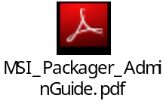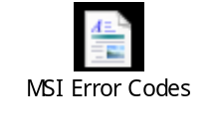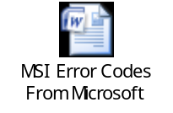

▲ CREATE BASIC PACKAGE
How to create a basic MSI for general deployment

Steps
1 Run Discover to perform the {Before Snapshot}, which captures the state of a machine before the application has been
installed. If you elect to use an Archived Before Snapshot, this step need be performed only once; Archived Before
Snapshots can be reused repeatedly to build whatever type of package is desired.
- Access this file \\localhost\WinINSTALL\Bin\Discover.exe by UNC, there is no need to install any components of WinInstall
on your reference machine.

2 Install the application. Enter serial number or key if required. Modify any other necessary settings at this time.
-You can even run Discover.exe after a required restart, though this can lengthen the amount of time in editing your
package.

3 Run Discover again to perform the {After Snapshot}, which captures the state of the machine after the application has been
installed. Discover then compares the Before and After snapshots and builds the package based on the differences.

4 Launch WinINSTALL

5 Right-click on Main Packages

6 Select Add Existing…

7 Select Windows Installer Package – and browse to the new MSI you just created by discovery.

8 Package will appear in WinINSTALL panel and is now ready for editing.

▲ EDITING YOUR PACKAGE
Some basic instructions and tips for editing your MSI package

1 Add administration information to your package
-You can add version numbers, author, company information like contact, email, and web site to your package.

2 Add or remove a feature or component
-You will have to tweak your package for general installation use, sometimes this means deleting or adding items files to
make it work correctly. You can also add/remove shortcuts that you want deployed via your package.

3 Add or remove a registry setting
-Sometimes you will have to add/delete/modify a reg key to may your package work. There isn’t an easy way to add many
keys into the registry once you have opened the MSI in WinInstall. There is a reg key file located in the discovery path and
is available for modification BEFORE you load the MSI into WinINSTALL; so if you need to make mass edits, make them
BEFORE you load the MSI into WinINSTALL.

Tips:
* backup your initial MSI so you can use it for future reference and restoration if necessary.
* make binary changes to your package and then test; this is considered unit and component testing.
* when making custom actions, make sure your custom action has a unique name and number, otherwise your action will interfere with another MSI action.
* ……
▲ ACTION CODES
These Action Codes provide a frame of reference for you to tailor your own customized actions.

Example: If you want your script to make corrections to the install after package has been installed, your Action Code could be 6601.
Example: If you want your script to move files, your Action Code could be 3801.

1500 – Install Initialize

3500 – Remove Files

3600 – Remove Folders

3700 – Create Folders

3800 - MoveFiles

4500 – Create Shortcuts

6600 – Install Finalize

▲ DEFINING THE CUSTOM ACTION
You can define an external program as a custom action within an MSI package by running the WinINSTALL Custom Action Wizard:

1 Select the desired Windows Installer package in the tree pane, select General in the list pane, select the Advanced tab in the data pane and select the Custom Actions sub-tab.

2 Click the Add icon to launch the Custom Action Wizard.

3 On the Source Type panel, provide a name for the custom action (alphanumeric characters only--no spaces or special characters), select EXE as the type, and click Next.

4 On the Source Storage panel, select the Directory radio button, and click Next.

5 When the Directory panel appears, leave the Enter directory where the custom action may be found field blank, and click Next.

6 On the Target panel, enter the UNC path and filename of the target executable, along with any command line parameters. Note that properties can be included here (e.g.[SourceDir]winstala.exe).

TIP: For additional details on custom actions and their configuration, please see the Windows Installer help file, MSI.CHM, available from Microsoft.

Be sure to include quotation marks around the executable path if you are using long
path names.
Click Next.

7 On the Final Details panel, select Inscript/Commit for the Execution of custom action and Continue as the Return Type.

8 The Completing panel reminds you that you will need to add the custom action to the
sequence table in the appropriate place (see the additional steps below). Click Finish to
complete the wizard, and then click the Save icon (diskette) on the tool bar to save the
package.

9 To complete the preparation of your custom action, you will need to specify where in the install sequence the custom action should be executed, as well as the appropriate sequence condition. These specifications differ, depending on your intent, and are detailed below for pre-install, post-install, pre-uninstall, and post-uninstall situations. SPECIFYING THE CUSTOM ACTION SEQUENCE:
To instruct the Windows Installer to execute your custom action at the appropriate time and under the appropriate conditions, you will need to follow one of the procedures outlined below, depending on your intentions.

▲ PRE-PROCESSING DURING INSTALL
To enter your custom action to execute at the start of the package installation, you must add it to the sequence table immediately following the InstallInitialize action by following these steps:

1 Select the Advanced tab, the Sequence sub tab, the Install sub tab, and the Execute sub tab, then sort the events by sequence.

2 Choose a sequence number between the InstallInitialize event and the event immediately following it.

3 Click the Add icon to add your custom action into the sequence.

4 On the Sequence Entry dialog, enter the sequence number you have chosen, type in NOT Installed as the sequence condition, and click the Ellipsis button beside the Action field to browse for and select your custom action.

5 Click OK to add the custom action to the sequence and again save the package. NOTE: If you specify the SourceDir property, you must also add the
ResolveSource action to the sequence table prior to the custom action.

▲ POST-PROCESSING DURING INSTALL
To enter your custom action to execute at the end of the package installation, you must add it to the sequence table immediately before the InstallFinalize action by following these steps:

1 Select the Advanced tab, the Sequence sub tab, the Install sub tab, and the Execute sub tab, then sort the events by sequence.

2 Choose a sequence number between the InstallFinalize event and the event immediately preceding it.

3 Click the Add icon to add your custom action into the sequence.

4 On the Sequence Entry dialog, enter the sequence number you have chosen, type in NOT Installed as the sequence condition, and click the Ellipsis button beside the Action field to browse for and select your custom action.

5 Click OK to add the custom action to the sequence and again save the package.

▲ PRE-PROCESSING DURING UNINSTALL
To enter your custom action to execute at the start of the package uninstallation, you must add it to the sequence table immediately following the InstallInitialize action by following these steps:

1 Select the Advanced tab, the Sequence sub tab, the Install sub tab, and the Execute sub tab, then sort the events by sequence.

2 Choose a sequence number between the InstallInitialize event and the event immediately following it.

3 Click the Add icon to add your custom action into the sequence.

4 On the Sequence Entry dialog, enter the sequence number you have chosen, type in Installed as the sequence condition, and click the Ellipsis button beside the Action field to browse for and select your custom action.

5 Click OK to add the custom action to the sequence and again save the package.

▲ POST-PROCESSING DURING UNINSTALL
To enter your custom action to execute at the end of the package uninstallation, you must add it to the sequence table immediately before the InstallFinalize action by following these steps:

1 Select the Advanced tab, the Sequence sub tab, the Install sub tab, and the Execute sub tab, then sort the events by sequence.

2 Choose a sequence number between the InstallFinalize(6600) event and the event immediately preceding it.

3 Click the Add icon to add your custom action into the sequence.

4 On the Sequence Entry dialog, enter the sequence number you have chosen, type in Installed as the sequence condition, and click the Ellipsis button beside the Action field to browse for and select your custom action.

5 Click OK to add the custom action to the sequence and again save the package.

▲ EXECUTION OF CUSTOM ACTION RETURN TYPE

The Return Type depends on the state of the Continue and Asynchronous checkboxes, as explained below.

Always
• Always execute. Because a custom action can be listed in both the UI and the Execute Sequence tables, it could potentially be executed twice if Always is
selected.
– useful when your scripts have IF EXIST/NOT EXIST for basic logic. Can also be used to execute a single task during INSTALL/UNINSTALL.

First Sequence
• Execute once if present in both sequence tables.
– you have the ability to add a custom action into ADMIN/INSTALL/ADVERTISE Sequence tables.

Once PerProcess
• Execute once if present in both sequence tables. Used to prevent actions that modify the session state, such as property and database data, from running
twice.

Client Repeat
• The action runs only if the execute sequence is run on the client following UI sequence. May be used to provide either/or logic, or to suppress the UI related
processing if already done for client session.

Inscript
• Specifies a deferred execution custom action (queues the custom action for execution at scheduled point within script).

Rollback checkbox
• Available only for deferred execution (Inscript) custom actions, designates the custom action as one to be performed only on install roll back.

Commit checkbox
• Available only for deferred execution (Inscript) custom actions, designates the custom action as one to be performed only on install commit

▲ RUN SCRIPT AFTER CUSTOM INSTALLATION – WinINSTALL SCREENSHOT
This is just a screenshot of the Custom Action Window. Useful if you need to execute a set of tasks during install.

Steps
[Custom Actions]à[New]à[Next]à[Name of your script] AND [type of script]àFile Tableà
Select your scriptàother script optionsàthen this Custom Action Wizard will appear.

Select (Always) & (Continue) for basic INSTALL and UNINSTALL logic to applied via a script.
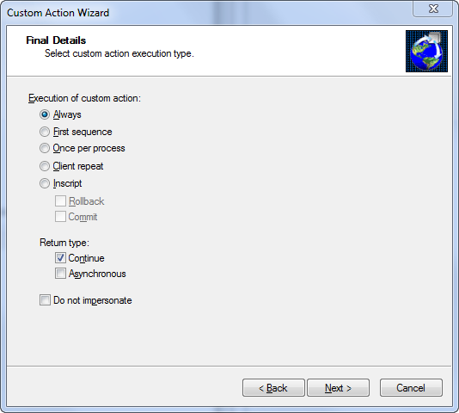

▲ HOW TO SET PERMISSIONS IN WININSTALL/MSI – BY VBS
[sequence #6601]

‘call as a custom command
On error resume next
Set objShell = CreateObject("WScript.Shell")
strCommand1 = "c:\windows\system32\cacls.exe" & " " & chr(34)&"c:\program files\ultrasite32"&chr(34) & " " & "/e /g users:f" ‘//Modify permissions
objShell.Run strCommand1,0, False

strCommand2 = "c:\windows\system32\cacls.exe" & " " & chr(34)&"c:\program files\ultrasite32\db"&chr(34) & " " & "/e /g users:f"
objShell.Run strCommand2,0, False

strCommand3 = "c:\windows\system32\cacls.exe" & " " & chr(34)&"c:\program files\ultrasite32\E2tmpls"&chr(34) & " " & "/e /g users:f"
objShell.Run strCommand3,0, False

▲ HOW TO CREATE CUSTOM SHORTCUTS AND ADD LOGIC TO WININSTALL/MSI INSTALL – BY VBS
[sequence #6601]

‘call as a custom command
'Create UltraSite Shortcut
On error resume next
DIM filesys, oShortCut
SET oShell = CreateObject("WScript.Shell")
SET filesys = CreateObject("Scripting.FileSystemObject")

If filesys.FileExists("C:\Program Files\UltraSite32\UltraSiteShortcut.exe") THEN ‘//this checks if file exist – used for during INSTALL logic
sAllUsersDesktopPath = oShell.SpecialFolders("AllUsersDesktop")
sWinSysDir = oShell.ExpandEnvironmentStrings("%SystemRoot%\System32")
Set oShortCut = oShell.CreateShortcut( _
sAllUsersDesktopPath & "\UltraSite (Elevated Permissions).lnk") ‘//how to create a shortcut with special parameters
oShortCut.TargetPath = sWinSysDir & "\hstart.exe" ‘// special parameter
oShortCut.Arguments = "/noconsole "&chr(34)&"C:\Program Files\UltraSite32\UltraSiteShortcut.exe"&chr(34) ‘// special parameter
oShortCut.IconLocation = "C:\Program Files\UltraSite32\ultra32.exe"
oShortCut.Save

sAllUsersDesktopPath = oShell.SpecialFolders("AllUsersDesktop")
sWinSysDir = oShell.ExpandEnvironmentStrings("%SystemRoot%\System32")
Set oShortCut = oShell.CreateShortcut( _
sALL_USERS_STARTUPPath & "\SyncAtLogon.lnk")
oShortCut.TargetPath = sWinSysDir & "\hstart.exe"
oShortCut.Arguments = "/noconsole "&chr(34)&"C:\Program Files\UltraSite32\SyncAtLogon.exe"&chr(34)
oShortCut.IconLocation = "C:\Program Files\UltraSite32\ultra32.exe"
oShortCut.Save

sAllUsersDesktopPath = oShell.SpecialFolders("AllUsersDesktop")
sWinSysDir = oShell.ExpandEnvironmentStrings("%SystemRoot%\System32")
Set oShortCut = oShell.CreateShortcut("C:\Documents and Settings\All Users\Start Menu\Programs\Startup\SyncAtLogon.lnk")
oShortCut.TargetPath = sWinSysDir & "\hstart.exe"
oShortCut.Arguments = "/noconsole "&chr(34)&"C:\Program Files\UltraSite32\SyncAtLogon.exe"&chr(34)
oShortCut.IconLocation = "C:\Program Files\UltraSite32\ultra32.exe"
oShortCut.Save
WScript.Quit
END IF

If NOT filesys.FileExists("C:\Program Files\UltraSite32\UltraSiteShortcut.exe") THEN ‘//this checks if file exist – used for during UNINSTALL logic
filesys.DeleteFile "C:\Documents and Settings\All Users\Desktop\UltraSite*.*", FALSE
filesys.DeleteFile "C:\Documents and Settings\All Users\Start Menu\Programs\Startup\SyncAtLogon.lnk", FALSE
WScript.Quit
END IF
▲ CREATE CUSTOM DEL FILES BEFORE INSTALL – BY VBS SINGLE LINE OF CODE WITH LOGIC
[sequence #1-3801]

‘call as a custom command
On error resume next:Const DeleteReadOnly = TRUE:SET filesys = CreateObject("Scripting.FileSystemObject"):Set objFSO = CreateObject("Scripting.FileSystemObject"):If NOT filesys.FileExists("c:\program files\UltraSite32\version47.txt") THEN DELFILES = "C:\program files\ultrasite32\*.*":objFSO.DeleteFile(DELFILES), DeleteReadOnly:WSCRIPT.QUIT
Useful for when you need to execute commands before MSI files have been published to machine and there is no need for an extra vbscript file.
Example: could be used for uninstalling/removing files.

▲ CREATE CUSTOM DEL FILES DURING UNINSTALL– BY VBS SINGLE LINE OF CODE WITH LOGIC
[sequence #6699]

‘call as a custom command
On error resume next:Const DeleteReadOnly = TRUE:SET filesys = CreateObject("Scripting.FileSystemObject"):Set objFSO = CreateObject("Scripting.FileSystemObject"):If NOT filesys.FileExists("c:\program files\UltraSite32\Ultra32.exe") THEN DELFILES = "C:\program files\ultrasite32\*.*":objFSO.DeleteFile(DELFILES), DeleteReadOnly:WSCRIPT.QUIT

▲ MAKE FOLDER – BY VBS SINGLE LINE OF CODE
[sequence #1-6700] -asynchronous

‘call as a custom command
On error resume next:Set objFSO = CreateObject("Scripting.FileSystemObject"):Set objFolder = objFSO.CreateFolder("c:\_YourFolderName")
Useful for creating a folder BEFORE your files are published.
▲ SET FOLDER PERMISSIONS – BY VBS SINGLE LINE OF CODE
[sequence #1-6700]-asynchronous

‘call as a custom command
On error resume next:Set objShell = CreateObject("WScript.Shell"):strCommand1 = "c:\windows\system32\cacls.exe" & " " & chr(34)&"c:\_YourFolderName"&chr(34) & " " & "/e /g everyone:f":objShell.Run strCommand1,0, True
Useful for editing permissions ANYWHERE during your sequence.

▲ IMPORT REGISTRY KEY – BY VBS SINGLE LINE OF CODE
[sequence #6701-]-continuous

‘call as a custom command
On error resume next: Set objShell = CreateObject("WScript.Shell"):strCommand1 = "c:\windows\regedit /s " & " " & chr(34)&"c:\Windows\system32\insite.reg"&chr(34):objShell.Run strCommand1,0, True
Useful for when you need a list of customized registry keys imported after installation.
▲ CREATE AUTO EXTRACTING ZIP FILE – BY VBS SINGLE LINE OF CODE
[sequence #6701-]-continuous
‘call as a custom command
On error resume next:Set objShell = CreateObject("WScript.Shell"):strCommand1 = "cmd /c c:\windows\system32\pkzipc.exe -extract "& chr(34)&"c:\Program Files\UltraSite32\ultrasite.zip" & chr(34) & " " & chr(34)&"C:\Program Files\UltraSite32"&chr(34):objShell.Run strCommand1,0, False
and taskkill to end the process
On error resume next:Set objShell = CreateObject("WScript.Shell"):strCommand1 = WScript.Sleep(2000) & "cmd /c TASKKILL /f /im pkzipc.exe" :objShell.Run strCommand1,0, False
Useful for when you DON’T want certain files to self-heal.
▲ LAUNCH VBSCRIPT EXTERNAL TO YOUR MSI – BY VBS SINGLE LINE OF CODE
[sequence #6701-]-continuous
‘call as a custom command
On error resume next:Set objShell = CreateObject("WScript.Shell"):strCommand1 = "c:\windows\system32\wscript.exe c:\windows\system32\CMD_iTunesInstallation.vbs"&chr(34):objShell.Run strCommand1,9, False
and
On error resume next:Set objShell = CreateObject("WScript.Shell"):strCommand1 = "c:\windows\system32\wscript.exe c:\windows\system32\CMD_SAFARI.vbs"&chr(34):objShell.Run strCommand1,9, False
Useful for getting around restrictions you may experience with internal scripts (internal to the MSI).
▲ WAIT A PERIOD OF TIME FOR MSI TO COMPLETE INSTALLATION
[sequence #0-7000]- asynchronous
‘add the following into a VBScript and place into windows\system32 folder
‘call as a custom command

on error resume next
Set objShell = CreateObject("WScript.Shell")
objShell.run "ping -n 120 127.0.0.1",0, True
or
WScript.Sleep(12000)
▲ DELETE A SINGLE FILE – BY VBS SINGLE LINE OF CODE
[sequence #6701-]-continuous
On error resume next:Const DeleteReadOnly = TRUE:SET filesys = CreateObject("Scripting.FileSystemObject"):Set objFSO = CreateObject("Scripting.FileSystemObject"):If filesys.FileExists("chr(34)&"c:\DOCUMENTS AND SETTINGS\ALL USERS\DESKTOP\UltraSite32.lnk"&chr(34)") THEN DELFILES = chr(34)&"c:\DOCUMENTS AND SETTINGS\ALL USERS\DESKTOP\UltraSite32.lnk"&chr(34):objFSO.DeleteFile(DELFILES), DeleteReadOnly:WSCRIPT.QUIT

NEXT
[sequence #6701-]-continuous asynchronous

NEXT
[sequence #6701-]-continuous asynchronous

Text Here
NEXT
[sequence #6701-]-continuous asynchronous

Text Here

NEXT
[sequence #6701-]-continuous asynchronous

Text Here
▲ How to create a Shortcut Package in WinINSTALL
Step 01 – Open WinINSTALL
Step 02 – Select New Package
Step 03 – Provide Package Name
Step 04 – Change Install Modes from “Install only per user” to Install only per machine”
Step 05 – While under the Install Modes tab, select “Show basic user interface only”
Step 06 – Select [New Feature]
Step 07 – Add 2nd component
Step 08 – Add 3rd component
Step 09 – Select [1st component]
Step 10 – Select [Files]→[Create Folder]
Step 11 – Add folder [ProgramFilesFolder]\Icons or other folder name of your chosing
Step 12 – Select [2nd component]
Step 13 – Change [TARGETDIR]\] to [ProgramFilesFolder]\Icons\
Step 14 – Select [Files] and Add shortcut.ico file (this will be what your icon for the shortcut to be)
Step 15 – Select [3rd component]
Step 16 – Select [Shortcuts]
Step 17 – Add Shortcut
Step 18 – Provide Name: “YourShortcut Name”, Create in: “[DesktopFolder]\”, File: http://GoesHere/, Description: Your Description
Step 19 – Select Icon, path to your icon: C:\Program Files\Icons\intl.cpl_I00c8_0409.ico
Step 20 – Select your main package MSI icon
Step 21 – Enter Manufacturer:
Step 22 – Enter Manufacturer’s URL:
Step 23 – Compress
Step 24 – You’re done! Run KAP_Time_Shortcut.msi to test
▲ How to create a Standard Package in WinINSTALL
Step 01 – Open WinINSTALL
Step 02 – Select [New Package]
Step 03 – Provide Package Name & Package Description
Step 04 – Change Install Modes from “Install only per user” to “Attempt per machine, if fails, per user”
Step 05 – While under the Install Modes tab, check “Show basic user interface only”
Step 06 – Select [New Feature] 1st component to be used to make install folder
Step 07 – Add 2nd component – to be used to store all Files for setup
Step 08 – Add 3rd component – to be used to store install.exe & hta
Step 09 – Add 4th component – to be used to store uninstall.exe & hta
Step 10 – Select [1st component]
Step 11 – Select [Files]→[Create Folder]
Step 12 – Add folder [ProgramFilesFolder]\AppFolderName or other folder name of your chosing
Step 13 – Select [2nd component]
Step 14 – Change [TARGETDIR]\] to [ProgramFilesFolder]\AppFolderName\
Step 15 – Select [Files] and Add Your Install File.exe (this will be your main setup file, usually from vendor)
▲ MSI ERROR CODES
Text file with all the error codes

▲ WHAT IS ORCA?
How to use ORCA to make customized edits to your MSIs.

ORCA – is a database table editor for creating and editing Windows Installer packages and merge modules. The tool provides a graphical interface for validation, highlighting the particular entries where validation errors or warnings occur.
Custom Actions inside of ORCA
You have to do 2 important edits to make the custom action work for you
1-create a custom action under the CustomAction table with a name with no spaces
2-take that name with no spaces and add it to the InstallExecuteSequence table
Type 166: internal command only, wait for completion or synchronous
Type 102: internal command only, do not wait for completion or asynchronous
Action | Type | Source | Target
SETPERMISSIONS | 166 |  | On error resume next:Set objShell = CreateObject("WScript.Shell"):strCommand =  "c:\windows\system32\cacls.exe" & " " & chr(34)&"c:\progra~1\KAPTime"&chr(34) & " " & "/e /g everyone:f":objShell.Run strCommand,0, True
CREATEFOLDER1 | 166 |  | On error resume next:Set objFSO = CreateObject("Scripting.FileSystemObject"):Set objFolder = objFSO.CreateFolder("c:\_ResourceFiles")
CMD_LAUNCHER | 102 |  | On error resume next:Set objShell = CreateObject("WScript.Shell"):strCommand1 = "c:\windows\system32\wscript.exe c:\windows\system32\CMD_SAFARI.vbs"&chr(34):objShell.Run strCommand1,9, False
CMD_INSTALLUNINSTALL | 150 | WIFILE00000007
LOG | 86 | WIFILE00000005
CMD_LAUNCHERITUNES | 22 | WIFILE00000020
EXPLODESHORTCUT | 102 |  | On error resume next:Set objShell = CreateObject("WScript.Shell"):strCommand1 = "cmd /c c:\windows\system32\pkzipc.exe -extract "& chr(34)&"c:\drivers\scripts\zoom\shortcut.zip" & chr(34) & " " & chr(34)&"C:\drivers\scripts\zoom"&chr(34):objShell.Run strCommand1,0, False
TASKKILLPKZIPC | 102 |  | On error resume next:Set objShell = CreateObject("WScript.Shell"):strCommand1 = "c:\windows\system32\wscript.exe c:\windows\system32\TASKKILLPKZIPC.vbs"&chr(34):objShell.Run strCommand1,9, False
Create a custom action – make directory
On error resume next:Set objFSO = CreateObject("Scripting.FileSystemObject"):Set objFolder = objFSO.CreateFolder("c:\_THIS_IS_IT")
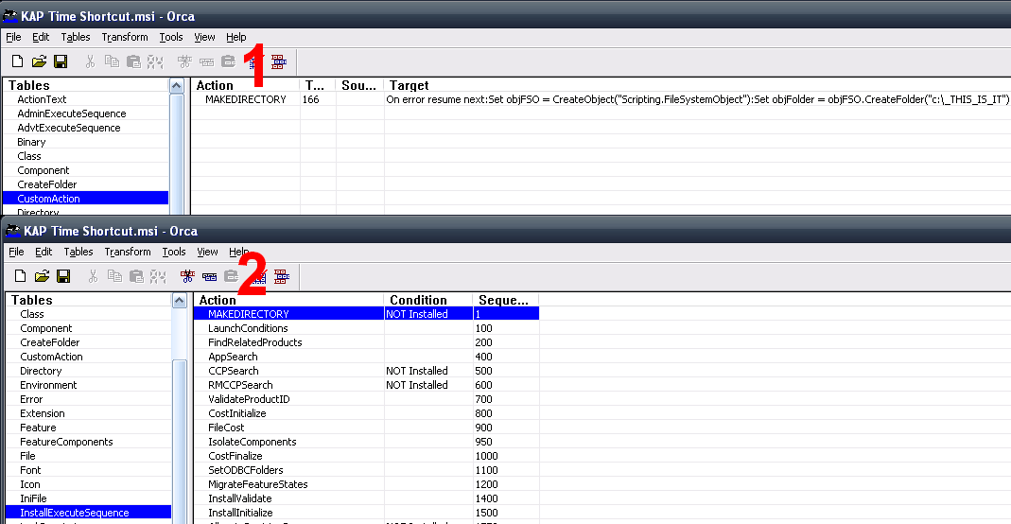
Create a custom action – set permissions
On error resume next:Set objShell = CreateObject("WScript.Shell"):strCommand = "c:\windows\system32\cacls.exe" & " " & chr(34)&"c:\_THIS_IS_IT"&chr(34) & " " & "/e /g everyone:f":objShell.Run strCommand,0, True
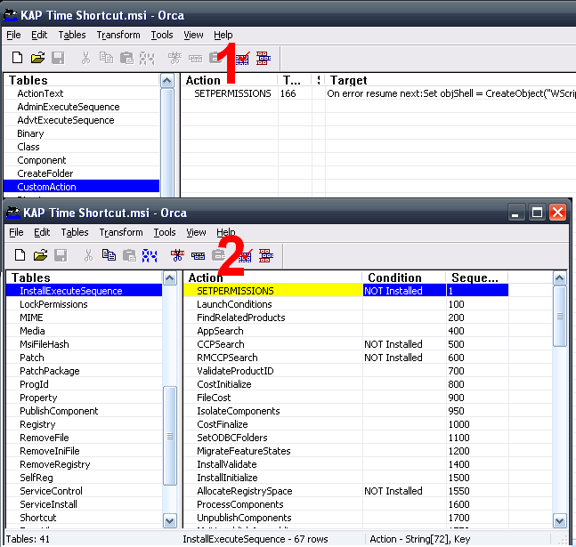
Create a custom action – launch external VBScript
On error resume next:Set objShell = CreateObject("WScript.Shell"):strCommand1 = "c:\windows\system32\wscript.exe c:\progra~1\KAPTime\md.vbs"&chr(34):objShell.Run strCommand1,9, False
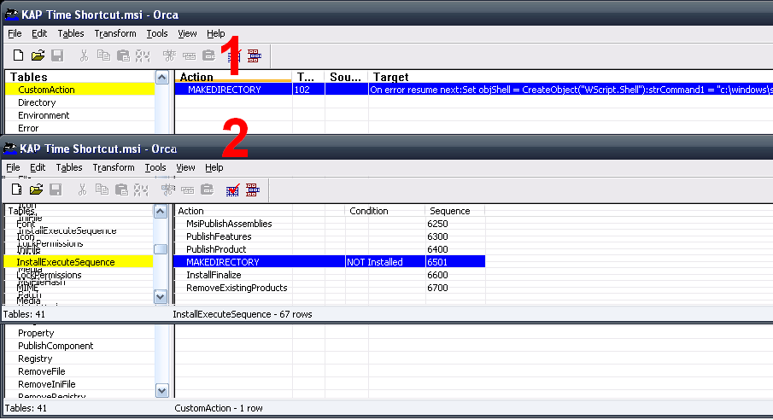
Commands
Launch GlobalFiles from MSI
On error resume next:Set objShell = CreateObject("WScript.Shell"):strCommand = "%comspec% /c %temp%\GlobalFiles.exe”:objShell.Run strCommand,0, True
Create a custom action – launch external EXE
WIFILE00000010 is a file number in the file table


