Skipping F12, WDS Servers, and Zero Touch
This document contains
Skipping F12 when PXE booting from a WDS server
Important BCDEdit Method for BIOS F12
Skipping F12 when PXE booting from WDS
Using PXE is a pain when you have to hit F12 every time the machine/VM boots. Often I’ll power on the machine/VM, – and guess what? I’ve already missed the F12 boot and the machine/VM skips right by PXE.
So, a simple solution. You just need to modify the properties of the WDS server, and change PXEboot.com to PXEBoot.n12 in the ‘Default Boot Program’ section. Do this for both x86 and x64 versions if you deploy both OS types. Here’s a screenshot from my server 2003 box:
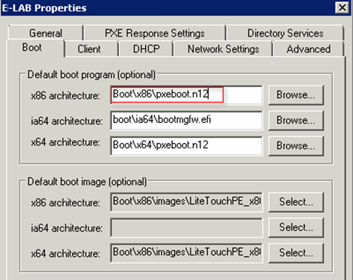
* Note, on a server 2008 box, there is an option to just skip the F12.
And there you have it. You no longer have to hit F12 to PXE boot directly into WDS menu!
From a forum
- Set WDS boot options to always require F12 from known and unknown clients.
- Boot a test system, it will PXE boot, then want a F12 key press to go into WDS
- Edit the 'netbootMachineFilePath' attribute of your test computers AD object. I set it to "192.168.1.1\boot\x86\pxeboot.n12"
- Reboot same test system
No F12 anymore for that test system!
Cleared the netbootfilepath value on my PC, rebooted it, and it still bypassed the F12 prompt and loaded the boot image.
So, it seems Active Directory/WDS still doesn't consider the PC to be staged, and I'm thinking that's related to the GUID of the PC, and therefore treats the PC as a new client - and all new clients get the F12 bypass. So, tomorrow morning when staff start turning up in their hundreds, I am going to have a big problem if they all load the boot image and not Windows!
However, I ran wdsutil /set-server /allown12fornewclients: no and rebooted. No boot-image load.
In summary, so far, I can specify and implement the F12 bypass by amending the default boot file in the WDS GUI, and this works perfectly. I can specify and implement the F12 bypass by changing the allowf12fornewclients setting in wdsutil, but this affects all our clients, not just new ones. And, even if this worked, it's not the target, because we want to specify a machine to reimage and not hope and pray the user hits F12 at the right screen.
Reference website: http://technet.microsoft.com/en-gb/library/cc753134%28v=ws.10%29.aspx
From a forum
In Windows Server 2008 R2, to skip pressing F12 on PXE boot, we have three methods to do so:
top
Method 1: Configure it from GUI Window. 1. Launch WDS in Windows Server 2008 R2. 2. Right click
the WDS server and choose Properties. 3. On the Boot tab, choose Always continue the PXE boot for known clients or unknown clients as necessary.
Method 2: Use WDSUtil command line utility to configure it. 1. If you want to specify the boot program
based on Architecture, please use the command below. WDSUTIL /Set-Server /BootProgram:<Relative Path> /Architecture: {x86|ia64|x64} For example: WDSUTIL /Set-Server /BootProgram:boot\x86\pxeboot.n12 /Architecture: x86 2. If you want to specify the boot program for the prestaged client computers, please use the command below. WDSUTIL /Set-Device /Device: <computer name> /BootProgram: <Relative path> For example: WDSUTIL /Set-Device /Device: Computer1 /BootProgram:boot\x86\pxeboot.n12
Method 3: Rename the n12 boot program pxeboot.n12 to the default boot program name pxeboot.com. 1. Under the directory of RemoteInstall\Boot\<Architecture>, rename the default boot program pxeboot.com to pxeboot.com.old. 2. Rename n12 boot program pxeboot.n12 to pxeboot.com. Therefore, if you would like to switch it back, please check the above settings.
Important BCDEdit Method for BIOS F12
The above information disables the F12 initiated by the WDS server; however, there is yet another (far more difficult) F12, and that is in the BIOS.
In many cases, there is NO way around having to press F12 to enter PXE mode; but, all is not lost. You can use the normal boot menu to implement a zero touch solution.
How the zero touch works is that you control a bcdedit.cmd file. You will deploy this file using your SCCM, LANDesk, Altiris, etc. The .cmd file gets deployed and executed, and the next time the workstation reboots (which also can be scheduled), it will automatically boot to a modified OS menu that has PXE options. In my particular case, I needed WDS PXE and LANDesk PXE to be available. What’s really cool about this method is that it is easy to deploy, easy to update, and there are no limits to how many different PXE configurations you can employ.
The .cmd file looks like this:
@echo off
color 0a
title Administrative Boot Loader

setlocal

:: Use the following set of commands to create a ramdiskoptions
:: object in the BCD store. The string "{ramdiskoptions}" is the
top
:: well-known name for the object's GUID.
:: please note, there are ways to uniquely identify the ramdiskoptions
::using GUIDs, however, I’m still researching and testing that
set bcdedit=%systemroot%\system32\bcdedit.exe
set bcdstore=c:\boot\bcd
rem WDS
bcdedit /create {ramdiskoptions} /d "PXE Boot"
bcdedit /set {ramdiskoptions} ramdisksdidevice partition=c:
bcdedit /set {ramdiskoptions} ramdisksdipath \boot\boot.sdi

rem Create a new boot entry.
bcdedit -create /d "WDS PXE Boot" /application OSLOADER
for /f "tokens=3" %%A in ('%bcdedit% -create /d "WDS PXE Boot" /application OSLOADER') do set guid1=%%A
echo The GUID is %guid1%

%bcdedit% /set %guid1% device ramdisk=[c:]\boot\wim\wds.wim,{ramdiskoptions}
%bcdedit% /set %guid1% path \windows\system32\boot\winload.exe
%bcdedit% /set %guid1% osdevice ramdisk=[c:]\boot\wim\wds.wim,{ramdiskoptions}
%bcdedit% /set %guid1% systemroot \Windows
%bcdedit% /set %guid1% winpe yes
%bcdedit% /set %guid1% detecthal yes
%bcdedit% /displayorder %guid1% /addlast
rem this sets WDS to be default
%bcdedit% /default %guid1%

rem LANDESK
bcdedit /create {ramdiskoptions} /d "PXE Boot"
bcdedit /set {ramdiskoptions} ramdisksdidevice partition=c:
bcdedit /set {ramdiskoptions} ramdisksdipath \boot\boot.sdi

rem Create a new boot entry.
bcdedit -create /d "LANDesk PXE Boot" /application OSLOADER
for /f "tokens=3" %%B in ('%bcdedit% -create /d "LANDesk PXE Boot" /application OSLOADER') do set guid2=%%B
echo The GUID is %guid2%

%bcdedit% /set %guid2% device ramdisk=[c:]\boot\wim\landesk.wim,{ramdiskoptions}
%bcdedit% /set %guid2% path \windows\system32\boot\winload.exe
%bcdedit% /set %guid2% osdevice ramdisk=[c:]\boot\wim\landesk.wim,{ramdiskoptions}
top
%bcdedit% /set %guid2% systemroot \Windows
%bcdedit% /set %guid2% winpe yes
%bcdedit% /set %guid2% detecthal yes
%bcdedit% /displayorder %guid2% /addlast
endlocal
pause
exit /b 0
Notes
Add the boot.sdi to c:\boot
Add the appropriate boot wims to c:\boot\wim
boot menu with PXE additions
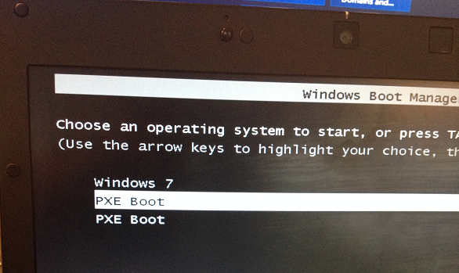
The first PXE Boot is WDS.
top
The second PXE Boot is LANDesk.
This setting can be controlled via the .cmd file and your deployment management software.
top

