October 20, 2011

Elite Packaging
For the Windows Platform
Plus media clips for learning

Packaging
…is the science, the art, and the technology
of enclosing or protecting software products
for distribution, storage, sale, and use…you
will package to meet the needs and requests
of your customer.

Benefits of Packaging

● Help administrators deploy software
configuration – built-in custom configuration
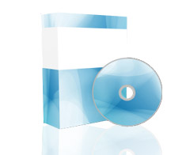
● Create reliable packages that can be
successfully distributed throughout an
organization – for enterprise delivery
● Minimize administrative errors during
installation – built-in logic to handle errors
● Provide features that help streamline
application – automate prompts, custom splash
● Reduce maintenance – provide backend support
● Eliminate unnecessary application
deployments
● Reduce complexity for support services
● Reduce training of support services

1 © Copyright 1993-2011 MrNetTek http://eddiejackson.net
Media Clips

● Application Packaging Explained Visually
http://www.youtube.com/watch?v=gg6s2YAImxI
● Application Packaging with MSI Studio
http://www.youtube.com/watch?v=O9CumMAnfP4

● Converting EXE to MSI using Wise
http://www.youtube.com/watch?v=quY_a7Ye_WQ
● Wise Setup Capture
http://www.youtube.com/watch?v=tQW1nnuD-1g
● WinInstall MSI Packager version 10
http://www.youtube.com/watch?v=pZzCSrLdf60
● Install Software through Group Policy
http://www.youtube.com/watch?v=JRNCgvZs5v4
● Flexera Software
http://www.youtube.com/watch?v=tZSkQbJWUtA
● Repackaging
http://www.youtube.com/watch?v=5nAwd2JZjUA

2 © Copyright 1993-2011 MrNetTek http://eddiejackson.net

Globally – Windows Packaging

● This area is poorly standardized in general, except Windows Installer

● No significant research or attempts to provide complex patterns

● Requires system hardware and deep software configuration knowledge

● Big amount of custom vendor specific solutions different by design

● Most organizations have their own internal installation frameworks

● Quality is critical - error localization is complex and resourceful
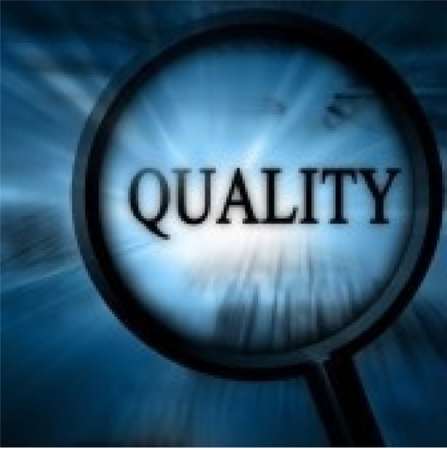

3 © Copyright 1993-2011 MrNetTek http://eddiejackson.net

Purpose of this Document

● To share my experience

● To get feedback from you
● To know more about latest news in
this area
● Email: MrNetTek2000@yahoo.com

● Site: http://eddiejackson.net

4 © Copyright 1993-2011 MrNetTek http://eddiejackson.net

Welcome to the REAL WORLD
The world of packaging is what you make it

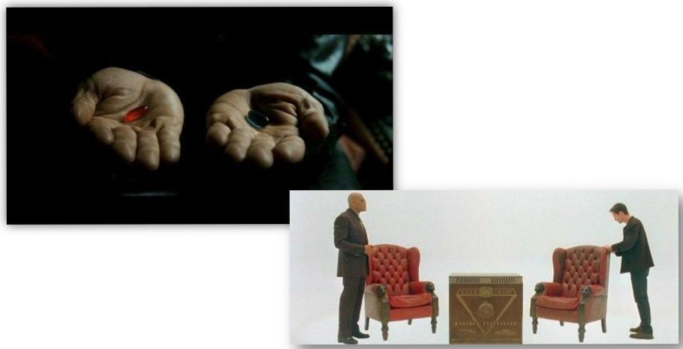

5 © Copyright 1993-2011 MrNetTek http://eddiejackson.net

Typical Errors to Avoid

● Develop installation as a software product with the same or lower quality
● Change internal package design
without informing customer

● Prioritize application features and quality in expense of packaging
● Start packaging soon before the critical delivery

6 © Copyright 1993-2011 MrNetTek http://eddiejackson.net

Typical Errors to Avoid

● Don’t invest in the packaging
design and infrastructure

● Remove garbage from the build outputs right before the final delivery
● Try to automate process without knowledge of the customer requirements
● Limited ability to say “No” and in
decision making
● Try to integrate in every project ecosystem completely

7 © Copyright 1993-2011 MrNetTek http://eddiejackson.net

Packaging - Inputs

Project
2
Project
3

Retail
Market

Project
1

Packaging

Team
Engineer

Conflict with Scrum!

Packaging Team
SaaS
Consulting

8 © Copyright 1993-2011 MrNetTek http://eddiejackson.net

What to do in Packaging

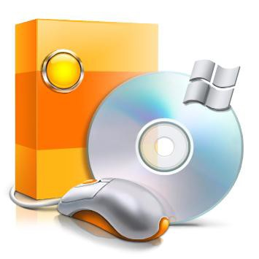
- Gather the application requirements

02. Get the initial deliverables version

03. Provide feedback and ensure that you
can satisfy most stakeholders
04. Agree on the common rules and achieve
acceptable compromise if needed
05. How to localize application related errors

06. Create acceptance and internal test cases

07. Create test environment if possible

08. Create or update installation package

09. Save sources and binaries

10. Delivery for the internal, application and
customer care testing
11. Documentation update

9 © Copyright 1993-2011 MrNetTek http://eddiejackson.net

There are many Development Platforms

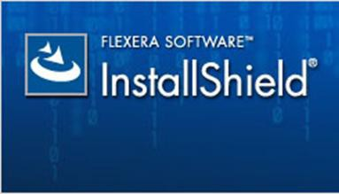

InstallScript, Framework
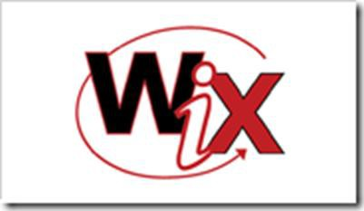

MSI, VBScipt

MSI, .NET
● Snapshot technology; Prism Deploy

● MSI Windows Installer in general

● InstallShield 11-2011, VBScript, InstallScript, now mostly WIX DTF
● Visual Studio 2008, 2010, .NET 2.0
– 4.0

● Highly fragmented proprietary installation framework as a basis used by consultants based on
InstallShield/VBScript

Packaging

10 © Copyright 1993-2011 MrNetTek http://eddiejackson.net

Windows Installer XML

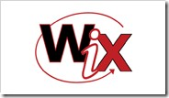
● WiX was developed by Microsoft software design engineer Rob Mensching
● Released to SourceForge in April of 2004 – first Microsoft open- source project
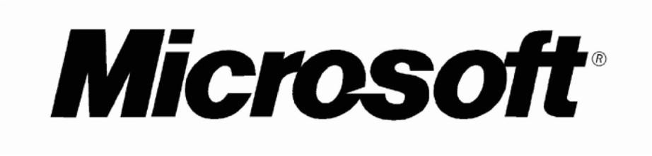
● Developers use their free time to participate in the development
● Everyone can join the project – code changes submitted via email
● After some successful changes –
direct access could be provided

11 © Copyright 1993-2011 MrNetTek http://eddiejackson.net

InstallShield

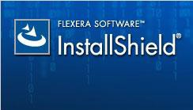
● Since 1992 InstallShield was
developed by Stirling Technologies

● Now InstallShield developed by Flexera Software owned by Thoma Cressey Bravo private fund
● Known industry standard

● Formerly InstallScript solution

● Successfully implemented support for Windows Installer technology
● Widely used by our Customer in
the most of the projects

● Now Limited Edition shipped with
Visual Studio 2010

12 © Copyright 1993-2011 MrNetTek http://eddiejackson.net

WIX – Current Use Case

Windows
Installer XML

Visual Studio
Shell
Command line tools

Documentation
Third party tools

Votive for Installation Package Design

DTF C# Custom Actions

Generate components by Heat tool

WYSIWYG user interface development

13 © Copyright 1993-2011 MrNetTek http://eddiejackson.net

InstallShield – Current Use Case

InstallShield

Native User
Interface
Visual
Studio
Bundled
Tools

Installation Package Design
VB Script Custom Actions
Context sensitive help

Generate
components
DTF or .NET Custom Actions
Compare two MSI packages

Create build
server

14 © Copyright 1993-2011 MrNetTek http://eddiejackson.net

WIX vs. InstallShield – Summary

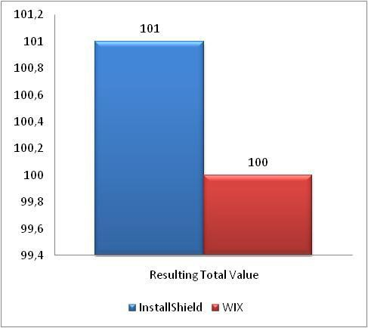
● InstallShield
  Globally InstallShield still standard
solution for the market
  More predictable, supported and controllable product
  Development is not too complicated, best installation visualization
  Very expensive

● Windows Installer XML
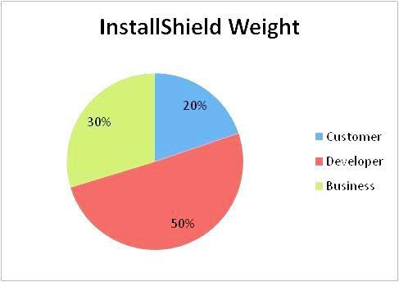
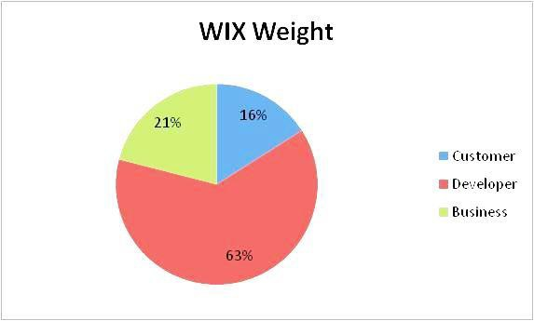
  Some concerns in regard of the customer orientation
  Business value is questionable, since the product life cycles and features hard to control or predict
  Best solution from developer’s point of view and a key of success
  Free

15 © Copyright 1993-2011 MrNetTek http://eddiejackson.net

As the result, compromise…

InstallShield 2011

&

WIX Deployment Tools Foundation

● Cheaper than the Premier Edition

● Concurrent licenses

● Multi-lingual support could be made in external UI

● InstallShield UI allows fast visualization and editing
of the MSI package

● WIX DTF and C# code handles most of the custom actions needed, especially for Silverlight and .NET based ones
● Now InstallShield bundled with the Visual Studio

16 © Copyright 1993-2011 MrNetTek http://eddiejackson.net

Automation Pros & Cons

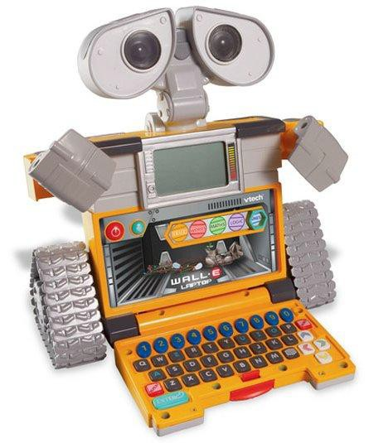
● When do you automate?

 Stable and mature project structure

  Well documented installation process

 Installation functional, delivered and approved by the customers
  Frequent updates are required

 Rare customer specific releases

● Where is it not needed?

  Requirements are not even or stable

  Frequent and significant application
design changes

 Rare updates, slow development

  Highly variable customer demands

  Customer specific deliveries

 Process is not documented

  Limited resources or budget

17 © Copyright 1993-2011 MrNetTek http://eddiejackson.net

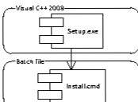
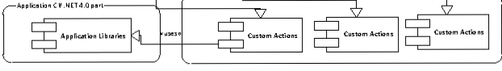
Experimental Design Pattern
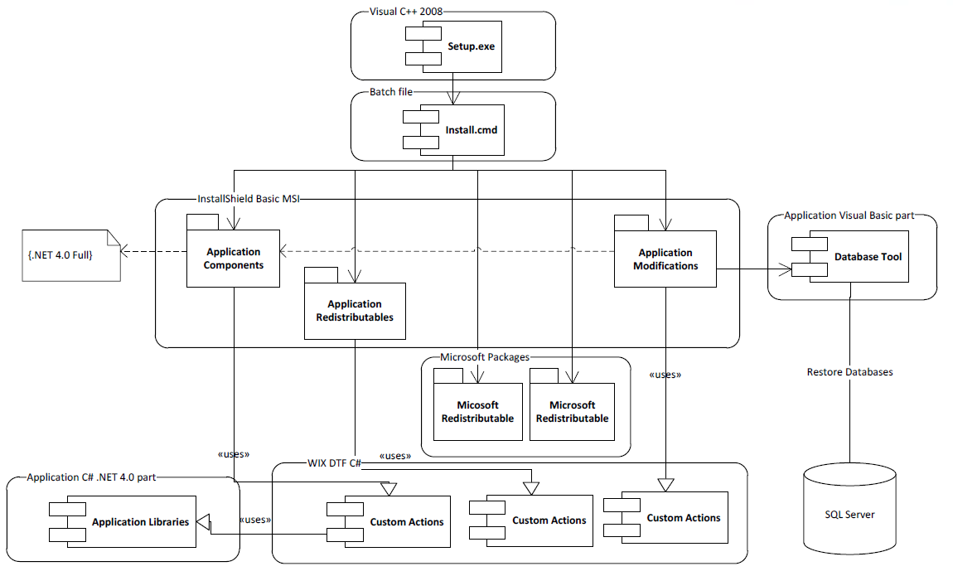

18 © Copyright 1993-2011 MrNetTek http://eddiejackson.net

Experimental Design Pattern

● Two packages per product
  Components for the files
  Mods for the environment config.

● Easy to localize the issue

● Faster to solve configuration related errors
● Reusable assemblies from the
application

● Functional template based on the InstallShield and WIX DTF, ready for the build automation
● Automated documentation processing

19 © Copyright 1993-2011 MrNetTek http://eddiejackson.net

Future of Packaging

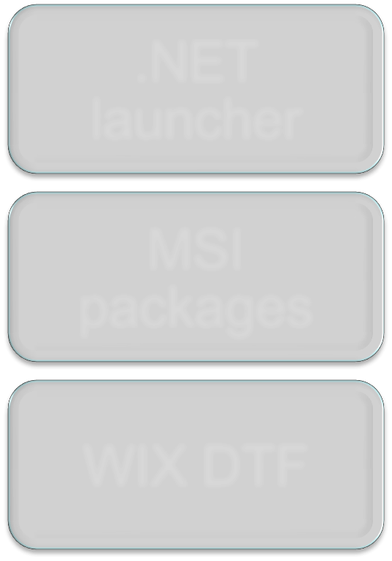

.NET
launcher

MSI
packages

WIX DTF
● InstallScript out of the market

● Windows Installer user interface will be hidden by custom .NET based solutions
● Silent mode used more and more

● Multi instance design as the requirement for growing ASP markets
● No VB or InstallScript inside the installation - .NET, C# and WIX DTF based solution
● Integration with the application assemblies
● Flexible build automation that will handle most of the customer related cases
● APPX and Windows Marketplace?

20 © Copyright 1993-2011 MrNetTek http://eddiejackson.net

...So, Don't be Just a Setup Monkey
Monkey see, monkey do – you can do better than that! You can be better than that!

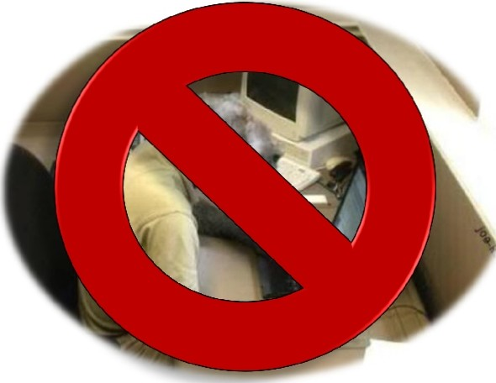

21 © Copyright 1993-2011 MrNetTek http://eddiejackson.net

Packaging Tools you could be using
 WinInstall, Flexera Admin Studio, MSI Pro, Prism Deploy Pictaker.exe
 VBScript - VBSEdit
 Notepad++
 Script-o-matic
 HTA-helpomatic
 WMI Explorer
 PrimalScript
 Audacity and Gimp

22 © Copyright 1993-2011 MrNetTek http://eddiejackson.net

That’s only the beginning…

23 © Copyright 1993-2011 MrNetTek http://eddiejackson.net

Future Topics
 Integrating Shell scripting into your packages
 Integrating VBScript scripting into your packages
 Integrating HTA scripting into your packages
 Adding splash screens to your packages
 Adding sounds to your packages
 Adding special effects to your packages
 Dealing with complex issues: permissions, registry, and multiple profiles

24 © Copyright 1993-2011 MrNetTek http://eddiejackson.net

