Ethics: Final Project
Eddie S. Jackson
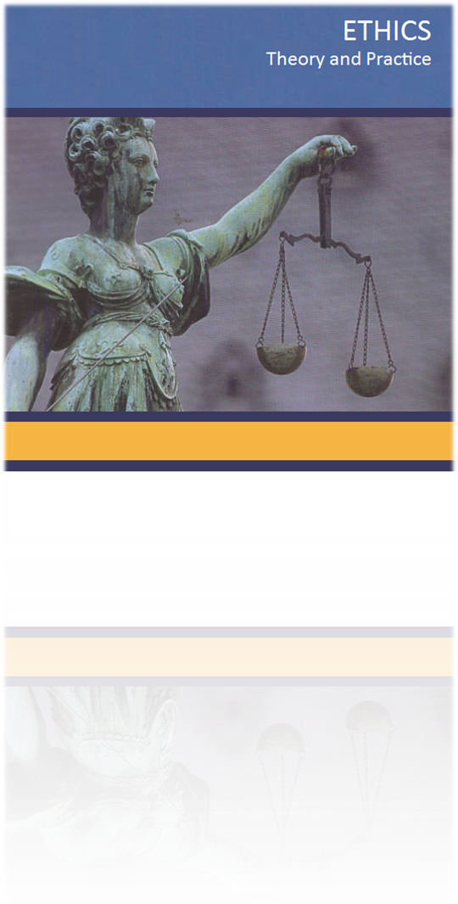

Final Project
Eddie S. Jackson
Kaplan University
HU245-04: Ethics

Introduction – Ethics and what it means to me……………………………………………….…...1
Analytical Skill Building – What skills did I gained throughout my Ethics studies?.......….…..2-3
Knowledge Acquisition – Why I acquired so much education through this Ethics course?...….4-6
Practical Application – How is what I learned applicable to real life?........……………………7-8
Conclusion……………………………………………………………………………………..….9
References……………………………………………………………………………………..…10
Introduction
Ethics and what it means to me
What is ethics and why is it important? When I think of ethics, I think of what is
basically right and what is basically wrong. What I have come to learn through this course is
that it really is so much more. Many moral ideas and ethical concepts are not in black and white,
and ethical and moral dilemmas do not necessarily have such simple solutions. Some common
circumstances where ethics can be applied are abortion, death penalties, discrimination, killing
animals for food, and recycling, just to name a few. And, the discussion of ethics is not
new; ethics has been contemplated by great men (and women) young and old, ancient and
modern. The philosopher Kant’s “Duty Ethics” included several ethical principles including his
belief that nothing was good in itself except good will. And, George W.F. Hegel’s work in
social-cultural determinism stated that we were not responsible or even have the ability to
control the period of time we are borne in. From Karl Marx and Sigmund Freud, to Aristotle
and Confucius, morality and ethics have been examined throughout history; and this essay
discusses such topics as well.
The content of this paper is laid out in three main sections: analytical skills building,
knowledge acquisition, and practical application. Analytical skills building will summarize the
many skills that I was able to fine-tune and sharpen throughout this course. Knowledge
acquisition will demonstrate the knowledge I acquired through displaying my own personal
work, as well as containing what I learned from each section. Practical application will show
real life scenarios and my knowledge put into action.
Analytical Skill Building
What skills did I gain throughout my Ethics studies?
In this ethics course I acquired new skills as well as sharpening skills like analytical thinking,
Index
1
writing, reading, and online correspondence. For the analytical skill we were asked to read case
studies, formulate opinions based our own experience and text book reading. There were many
instances where the case study rolled over into discussion questions and discussion questions
rolled over in into the seminar. We looked at the case studies in detail, and provided solutions or
arguments for or against a particular topic. In writing, we were always writing in discussion
questions and student responses. I utilized good writing skills to formulate responses to all the
main discussion questions as well as responding to student questions. In reading, we were asked
to read case studies, textbook readings, discussion questions and discussion threads, email, and
extra reading material like flash cards or further readings. The content was at college level and I
felt like it was really challenging. The best part of the class is the online correspondence. The
online seminars, discussion threads, and email were a part of the online correspondence. You
really got to think in class and hear the professor teach and respond to students’ questions. The
online portion is really skill all by itself that I was able to acquire.
One good example of analytical thinking was a discussion thread where we were asked
to respond to a question on morality and return ethical details one way or the other:
Question: Are there certain moral absolutes that we all should live by?
No, I do not believe so. My beliefs fall along the theories of Ross, who believes that
there are next to zero absolutes, and moral relativists that believe it is all relative
We as humans love attaching labels and boundaries to everything, including
morality. When will we learn that the complexity of our uniqueness is infinite? What’s
“bad” and what’s good” is so very obviously relative to one’s culture, societal norms,
and the individual’s personal experiences. Moral absolutes really have no place in the
America of today or tomorrow. You really want something to ponder about what’s right
and wrong? I think many (not all) of the “bad” things people do are really our own
shortcomings as a society, at least American society. Think about it. Most of what we
consider to be bad: stealing, lying, cheating, even murder are symptoms of a society
coming apart at the seams. For example, let’s take an inner city neighborhood (one of
many examples). The schools aren’t that great, with severely underpaid teachers, an
education system that is below C level, children go to broken homes with one parent
(who of course is an alcoholic or drug user). What do you think the chances that child
will not steal, lie, cheat, or even commit murder one day? It’s so easy to say someone is
doing something wrong, and as the consequentialist would say, there are consequences
for one’s actions. What about when a society fails the people? What about when
society is to blame for the problems it is plagued with? What are the consequences
then? I find it very interesting that the best we can come up with is taking a person who
has “done something bad” and slamming them with consequences, without factoring in
the person’s experiences and most of all, societal conditions, as they were.
The analytical skills I used most were reviewing a case study or reading discussion questions and
responses, and then thinking about my response based upon what I had read in my textbook,
other discussion threads and professor correspondence.
2
Knowledge Acquisition
Why did I acquire so much new education through this Ethics course?
I learned about many new ethical concepts such as: the meaning of morality, bioethics,
affirmative action, allowing someone to die, business ethics, and many others. I would like to
discuss just a few topics that will demonstrate the quality of conversation and some of the
knowledge obtained through academic discussions, live seminars, and instructor correspondence.
What is morality? Morality is what is good or what is right as it is determined by the
majority. Morality is our guiding light as humans. Do moral rights only belong to the majority?
I answer this question in an important discussion thread that we covered about morality:
Why don't we determine moral right and wrong by seeing what the majority of
people believe? That is, why don't we use prevailing social opinion?
And this was my response:
"I pledge allegiance to my Flag and the Republic for which it stands…”
I could be wrong, but I believe we live in a republic not a democracy. The difference
is every single person has rights that are afforded to them by the United States
Constitution, and those rights are not divisible by what the majority says, in fact it is
just the opposite. In a democracy, fifty-one percent determines the rights of the other
forty-nine percent, which is not the case in America. If we were to use prevailing
social opinion as our ethical system to determine morality, it would not take very
long before the minority, whoever they may be, would be severely oppressed by a
system that does not provide equality to everyone at all times. Don’t get me wrong,
our government actually does try to be "democratic" on certain issues, and we all
know where that ends up (usually in a filibuster or somewhere in a gray area).
3
3
4
What I learned about morality is that is just does not belong to one large group of people. It is
everyone’s responsibility as humans to do what is right, ethical, honest and sincere.
What is Bioethics and what does it have to do with abortion? This is cited from an
important discussion question:
As defined by our book, it is “life ethics”. The specific
Bioethics topic I would like to cover has to deal with abortion. There are
many important social and ethical questions surrounding abortion, thus
over time has formed large, opposing groups with valid arguments on both
sides. The two main forces at work here are pro-life and pro-choice, and if
I had to choose one or the other, I would choose pro-choice. The pro-
choice position is the definitive statement that it is a woman’s decision and
her choice of whether to have an abortion or not, and that no one should be
able to take that power from her. I believe in many scenarios that ethical
egoism and utilitarianism could be fulfilled by allowing women to have one
hundred percent control over their own bodies.
Ethical egoism seeks after self-interest, and for those that chose to have an
abortion, the self-interest variable will have been met. In the way of utilitarianism
(those that would seek what is best for everyone involved), take under consideration
that unwanted children heavily burden the education system, our healthcare
system, as well as can contribute to overall poverty, crime, and violence in
the long term; it would be better for everyone if abortions were accepted as
a common resolution of personal choice. There are also women’s rights
and privacy to be factored into the pro-choice equation. I believe if we are
to maintain freedom, privacy, and sensitivity to the bioethical issue of
abortion, along with supporting the uniqueness of each abortion itself, pro-
choice is the only choice.
What I learned about Bioethics is that issues like abortion do not necessarily have simple
5
solutions. With one decision you could be saving a life and enforcing the right to life concept,
but you could also be infringing on someone’s rights of personal freedom and privacy.
Another great knowledge acquisition was the study of affirmative action. Affirmative
action is a practice that serves us in issues of equality relating to religion, race, color, and gender.
It forces businesses and organizations to provide equality across the board when it comes to
career opportunities, fair treatment amongst personnel, as well as overall interest in social classes
perhaps not always in their best interest. In class, we had a case study where a university student
named Katie Sampson, who also was an African-American, wanted to do-away with the affirmative action policy at the school.
This was my response to that discussion question:
I do agree that affirmative action policies create a form of reverse
discrimination. However, America is quite well-known for its past
transgressions, especially when it comes to discrimination in the
workplace, and we need laws to address such business practices. I have
had many jobs throughout my career and sometimes I witnessed a
“status-quo” person being hired instead of the most qualified. And I
asked myself is this fair? Should quotas be filled? And the answer is
simple, the answer is yes. Why you ask? Because American business
isn’t about the little man, at least not anymore, it’s about the rich and
powerful, and the only way we can keep them honest is to force them to
recognize that hiring practices should be honest, fair, and most of all
diverse.
Through affirmative action we can accomplish just that. If you walk into
a law firm where there are hundreds of lawyers, and you happen to
notice they are all white males in their mid-30’s, I can almost guarantee
you that the rich and powerful are leveraging their weight against the
social classes as they were.
As far as Katie Sampson is concerned, I DO THINK that her proposal
should be rejected. Affirmative action combats discrimination and it is
America’s atonement for its past sins. I don’t believe Katie has the right
to take that away from those who may need it most.
7
What I learned about affirmative action is that it has been created to protect anyone that may be
discriminated against for many reasons including racism and other prejudices. I have learned it
is a good policy to have in place.
Practical Application
How what I learned is applicable to real life?
Throughout the ethics class, we discussed real questions and contemplated the many possible
solutions. There was one assignment in particular that I thought was very applicable to real life,
and that was a letter to our state governor to explain why capital punishment is ethically wrong.
This is an example of a practical situation as cited from my own work:
Dear Governor Rick Scott,
This letter comes to you with great intentions, expectations and with the
highest regard for American society; you can tell just how great a country is by
how well they treat the poor and less fortunate as well as how they process and
maintain their criminal justice system. I would like to express my deepest concern
for capital punishment and offer possible solutions to a system that currently does
not appear to be working. The reasons why capital punishment is ethically wrong
are: it is ineffective as a deterrent (murders happen whether or not there is capital
punishment), it does not bring back the victims (capital punishment would be an
act of revenge in this case), there is always the possibility of executing an innocent
man or woman (this would be a grave injustice), and the denial of rehabilitation of
the criminal (even if the criminal cannot be rehabilitated, they may still have
something valuable to offer society).
We all have heard of the arguments against
capital punishment, but what about the solutions? I believe we should do what is
best for everyone involved, including the criminals (a utilitarian approach). I
believe crime in America has roots in the socio-economic
problems that plague the poorest of neighborhoods, as well as corporate tyranny,
capitalism run amuck, monetary greed, and corrupt politicians. We need to clean
up America one neighborhood at a time, as well as balance the wealth, education,
and healthcare of this great country (all of these elements would lead to less crime,
crime that is punishable by capital punishment). We should change capital
punishment to life without a chance of parole, at least until we evolve morally and
ethically and can step into the future knowing more about crime, why it happens
and what role we play in it. Let us do what is best for everyone.
6
7
What I learned about capital punishment is that to murder someone for their crimes is not really
much better than the murderer themselves. I learned that we as humans have much to learn in the way of social justice, the reason why crimes actually happen, and rehabilitation.
Another great example of practical application is a discussion thread I participated in
concerning business ethics. Allen Lopez posts a satirical website resembling employee abuse at
his own company:
Would firing Allen Lopez violate his civil rights?
The simple answer is yes it would. Allen’s fictional company, though baring a resemblance,
does not give the company any rights. If Allen had named the company at the website, then of
course that would have been a problem. Government and corporate America already exert so
much control over our lives; I’m wondering what will be next? Will they tell us we can’t
smoke, drink, or even eat fast food while off the clock? If I were the one making the decision of
whether the company could take action against Allen or not, I’d tell them to get real and slam
the door in their face.
8
Do employers have an ethical duty to grant employees constitutionally protected civil
liberties like the freedoms of speech and expression or are there legitimate business
reasons for an employer to limit or abridge its employee’s civil rights while at work?
For as long as I can remember, I have been pro-employee. The company protects the company,
and as far as the employee is concerned, the employee protects themselves. With that said,
companies’ offer no more rights than they have to; most companies provide what is required by
law, and they take away everything else. Are there legitimate reasons to limit an employee’s
civil rights at work? Perhaps (maybe in rare situations), but employers tend to get carried away
and make irrational and rash decisions merely on a whim. They say things like "It’s to protect
the company", all while profits soar and employees get the blunt object. I believe if someone’s
fictional story on a website can bring down a company, then that’s a company that shouldn’t
have its doors open anyway. Business ethics is an oxymoron for sure. Businesses should do
more for their employees, including increasing civil liberties, like freedom of speech, even
within the workplace.
While not at work?
The only reason I can think of why a company would not allow full civil liberties at work is
control. They want to be able to control general employee population (they don’t want mobs
forming against the company). The problem with that, especially in Allen’s case, sometimes
there are legitimate reasons why employers and businesses need to listen and make changes.
Allen went to management, he tried going through all the right channels and he got shut down.
Some employers want machines, voiceless, faceless, and obedient machines.
Which ethical principles or questions are important to consider when deciding whether
"business interests" provide legitimate grounds for abridging civil rights?
The real problem I see with this is that business interests aren’t definitive. Business interests are
what they say they are, and can change frequently. I mean you have the obvious which is the
competitive edge, which is just another way of saying profitable. So, it all really comes down to
the numbers, to the bottom line (we’ve all heard this). The almighty dollar is why they abridge
civil rights. Pretty sad. America has built an empire around capitalism, with the façade of civil
liberties, justice, and equality. If you really want to see just how free you are, get between a
company and their bank account.
9
Many topics we covered in class could easily be applied to real life. From the death penalty to affirmative action, each topic we reviewed was also tied to real life circumstances; many of the students posted their own experiences, including myself.
Conclusion
Why is ethics important? Ethics is important because it is the fabric of humanity. We are all connected through our daily interactions with one another. And if you lie, cheat, steal, murder, discriminate, or fail to do the right thing or the moral thing, you could easily hurt those around you. There were many topics we covered from abortion, the death penalty, and discrimination, to killing animals for food and recycling. Each topic was taught in detail by our instructor and then reviewed and studied by me.
The three main points highlighted in this paper were analytical skills, knowledge acquisition, and practical application. My analytical skills were sharpened as I read case studies and discussion threads, and posted responses backed-up by our textbook and research. Knowledge acquisition came very easy as we made our way through each unit, attending seminars, answering discussion questions, and posting student responses. As far as practical application, there was not a single topic that we covered that did not have someone’s personal experiences to relate to the subject.
Overall, the ethics course was fantastic and I learned a lot about the world I live in. I was able to discuss important topics that every great mind should contemplate. The open forum, online experience, and course content only added to the academic learning process. The question I will leave you with, “Can the study of ethics possibly create a better human being?”
10
References
Thiroux, J, & Krasemann, K. (2009). Ethics: Theory and Practice. Upper Saddle River, NJ: Prentice Hall.
11

